JPL/USC GAIM: On The Impact of Using COSMIC And Ground-Based GPS Measurements To Estimate Ionospheric Parameters

Attila Komjathy, Brian Wilson, Xiaoqing Pi, Vardan Akopian, Miguel Dumett,
Byron Iijima, Olga Verkhoglyadova and
Anthony J. Mannucci

Jet Propulsion Laboratory/California Institute of Technology
4800 Oak Grove Drive, M/S 138-300
Pasadena, CA 91109

Abstract

The University of Southern California (USC) and the Jet Propulsion Laboratory (JPL) have jointly developed the Global Assimilative Ionospheric Model (GAIM) to monitor space weather, study storm effects, and provide ionospheric calibration for space weather applications. JPL/USC GAIM is a physics-based 3D data assimilation model that uses both 4DVAR and Kalman filter techniques to solve for the ion and electron density state and key drivers such as equatorial electrodynamics, neutral winds, and production terms.

Here we report on GAIM Kalman filter-based assimilation results using ground-based GPS and COSMIC-derived TEC measurements. We find that assimilating COSMIC measurements into GAIM improves critical ionospheric parameters such as NmF2 and HmF2. Assimilating COSMIC data produces higher accuracy vertical electron density profile “shapes”, as verified by comparisons to independent electron density profiles measured at Arecibo, Jicamarca and Millstone Hill Incoherent Scatter Radar (ISR). We also find significant improvement in global vertical TEC (VTEC) maps when assimilating COSMIC measurements, verified by comparing GAIM output with VTEC measurements from the JASON ocean altimeter. For three days in June 2006, improvement in accuracy compared to ground-data-only assimilation is found to be 30%, 28% and 44% respectively.

Introduction

Ionospheric remote sensing is in a rapid growth phase, driven by an abundance of ground and space-based GPS receivers, new UV remote sensing satellites, and the advent of data assimilation techniques for space weather. The success of the GPS/MET experiment in 1995 inspired a number of follow-on radio occultation missions for profiling atmosphere and ionosphere, including the Argentine Satelite de Aplicanciones Cientificas-C (SAC-C), the U.S.-funded Ionospheric Occultation Experiment (IOX), and Germany's Challenging Minisatellite Payload (CHAMP) [Jakowski et al., 2007]. The joint U.S./Taiwan Constellation Observing System for Meteorology, Ionosphere and Climate (COSMIC; http://cosmicio.cosmic.ucar.edu/cdaac/index.html), a new constellation of six satellites, nominally provides up to 3000 ionospheric occultations per day (Figure 1). The COSMIC 6-satellite constellation was launched in April 2006. COSMIC now provides an unprecedented global coverage of GPS occultation measurements (between 1400 and 2400 good soundings per day as of June 2009), each of which yields electron density information with ~1 km vertical resolution. Calibrated measurements of ionospheric delay (total electron content or TEC) suitable for input into assimilation models are currently made available in near real-time (NRT) from the COSMIC with a latency of 30 to 120 minutes. Similarly, NRT TEC data are available from two worldwide NRT networks of ground GPS receivers (~75 5-minute sites and ~125 hourly sites, operated by JPL and others). The combined ground and space-based GPS datasets provide a new opportunity to more accurately specify the 3-dimensional ionospheric density with a time lag of only 15 to 120 minutes. With the addition of the vertically-resolved occultation data, the retrieved profile shapes are expected to represent the hour-to-hour ionospheric “weather” much more accurately. We have now begun integrating COSMIC-derived TEC measurements with ground-based GPS TEC data and assimilating these data into models such as the JPL/USC Global Assimilative Ionospheric Model (GAIM) so that three-dimensional global electron density structures and ionospheric drivers can be estimated. Recently the COSMIC GPS measurements along with ground-based GPS measurements have been assimilated into JPL/USC GAIM for a study of ionospheric storm [Pi et al., 2009] revealing distinguished features of equatorial anomaly enhancements.

The arrival of global, continuous data sets from diverse sources such as over 1200 GPS receivers across the globe, satellite – satellite crosslink occultations, digisonde profiles, in situ satellite density measurements, and ultraviolet (UV) airglow measurements from low-Earth orbiters are fueling the need to create ionospheric models that are largely data-driven, such as the persistence-based multi-shell model, Global Ionospheric Mapping (GIM) [Mannucci et al., 1998; Saito et al., 1998; Komjathy et al., 2005; Hernandez-Pajares et al., 2008; Lee at al., 2008]. Three-dimensional tomographic models have been developed such as MIDAS [Dear and Mitchell, 2006], EDAM [Angling and Cannon, 2004], and others [e.g., Rius et al., 1997]. Approaches such as IDA3D [Bust and Crowley, 2007; Bust and Mitchell, 2008], attempt to incorporate data and ionospheric physics by use of empirical models (e.g. IRI) to help define the a priori state of the ionosphere prior to data input. In spite of high success in regions with excellent data coverage, these techniques are probably limited in forecasting ability. Newly emerging assimilative models use first-principles physics-based models and ingest data in order to merge the benefits of tomographic and physics-based techniques. JPL/USC GAIM [Pi et al., 2003; Hajj et al., 2004; Wang et al., 2004; Pi et al., 2004; Mandrake et al., 2005; Pi et al., 2009], USU GAIM [Schunk, 2002; Scherliess et al., 2006; Thompson et al., 2009], and the Fusion Numeric’s assimilation model [Khattatov et al., 2004; Angling and Khattatov et al., 2006] have all been developed to address this need, with significant variations in the forward modeling and data assimilation approaches. In this paper, we use an operational (real-time capable) version of the JPL/USC GAIM model and compare GAIM assimilation runs using ground-GPS-only and ground plus COSMIC measurements combined. In the results section, JPL/USC GAIM will be assessed using independent data sources such as incoherent scatter radar (ISR) derived electron density profiles and Jason VTEC measurements.

JPL/USC Global Assimilation Ionospheric Model

The University of Southern California (USC) and the Jet Propulsion Laboratory (JPL) have jointly developed GAIM to monitor space weather, study storm effects, and provide ionospheric calibration for space weather applications. JPL/USC GAIM is a physics-based 3D data assimilation model that uses both 4DVAR and Kalman filter techniques to solve for the ion and electron density state and key drivers such as equatorial electrodynamics, neutral winds, and ion production terms [Wang et al., 2004; Pi et al., 2003]. GAIM is capable of ingesting multiple data sources, updates the 3D electron density grid every 5-12 minutes, and solves for improved drivers every 1-2 hours. Since our forward physics model and the adjoint model were explicitly designed for data assimilation and computational efficiency, all of this can be accomplished on a single dual-processor Unix workstation.

In Figure 2, we describe the building blocks of the Kalman filter and the 4 Dimensional VARiational (4DVAR) data assimilation processes that are distinctly separate processes at this stage [Wang et al., 2004]. The GAIM forward ionospheric model (first-principles physics) is a global three-dimensional time-dependent model for ion densities. The conservation of mass and momentum equations are solved on an Earth-fixed Eulerian grid [Pi et al., 2003]. The volume elements have surfaces parallel to either the magnetic field and potential lines or geomagnetic meridional planes as illustrated in Figure 3. Using the most recent ionospheric “state” (ion densities in each volume element or voxel) and ionospheric driving forces, the forward model propagates the state to a future time. The observation operator maps the future state to the incoming measurements. These predicted measurement values are differenced from the actual measurements creating an “innovation vector”. In the assimilation step, the Kalman filter adjusts the electron densities based on the innovation vector and the prior covariance matrix to compute a statistically minimum variance estimate of the electron density. The Kalman filter works to reduce the residuals in a least squares sense over the entire grid at once, weighted by the uncertainty in each voxel and the uncertainty in the incoming data sources. In case of the 4DVAR approach, only the driving force parameters are adjusted to produce a least squares estimate of the driving forces as well as electron density [Pi et al., 2003].

The GAIM medium resolution assimilation runs we performed for most of this study use 2.5 and 10.0 degree resolution in latitude and longitude, respectively. We use 40 km as an approximate height resolution resulting in approximately 100,000 voxels globally (actual height resolution varies with latitude based on the pql grid as shown in Figure 3). We performed three types of runs: 1) GAIM climate (physics model only); 2) ground GPS TEC assimilation and 3) ground GPS and COSMIC data assimilation combined.

Data Sets and Processing

For profile validation, we chose three Incoherence Scatter Radar World Days in 2006: June 26, September 21 and December 20. For input data, TEC links from approximately 200 ground-based GPS receivers were used. GPS RINEX files were processed using the JPL Global Ionospheric Model (GIM) software suite to estimate the satellite and receiver differential delays. Subsequently, raw GPS phase-leveled line-of-sight TEC observables corrected for the satellite and receiver differential delays were generated [Mannucci et al., 1998]. This resulted in the absolute slant GPS-derived TEC observables that were directly used as input to GAIM. COSMIC raw data were also processed using the GIM software suite. The upper left panel of Figure 4, depicts the global GPS coverage for September 21, 2006, showing a dense but unevenly distributed coverage. The lower left panel shows the slant TEC measurements for station Istanbul. The P1-P2 pseudorange ionospheric observables (green) are dominated by multipath error, unlike the overlapping phase-leveled L1-L2 precise ionospheric observables (red lines). The upper right panel depicts the COSMIC coverage using six COSMIC satellites for that day, indicating less overlapping yet spatially spread coverage (note that individual measurements can be identified). Notice the difference between this figure and the inset plot (lower right panel) of COSMIC coverage in Figure 1. Figure 4 shows the geographic locations of individual GPS measurements while the lower right panel of Figure 1 indicates one symbol for each individual occultation. The lower right panel of Figure 4, displays the calibrated COSMIC TEC observations from setting occultations with elevation angles ranging between -25 to 80 degrees. The larger TEC values are located below 0 degrees since the COSMIC satellite orbits at 780 km altitude, above the F-region peak. The blue and red curves depict JPL and UCAR-processed ionospheric occultations showing good agreement between the processing centers. The small differences we observe between UCAR and JPL processed line-of-sight TEC measurements are due to different elevation cutoff angles and receiver bias estimation techniques used by the two processing centers [Schreiner et al., 1999; Syndergaard et al., 2005; Lei et al., 2007].

Analysis of Results

Our focus is on investigating the effect of COSMIC radio occultation measurements on estimated electron density profiles. We performed three different GAIM runs. In the first run, no data are assimilated. In that case, electron density profiles are determined by physics model (climate) only. The second GAIM run involved assimilating ground-GPS-data only. The third GAIM run involved assimilating ground-based and COSMIC TEC links simultaneously. On the upper left panel of Figure 5, COSMIC satellite tracks (trajectory of the tangent points for satellites FM2 and FM5; for definition see Hajj and Romans [1995]) are displayed in red and ground-based GPS ionospheric pierce points at 450 km altitude are shown in blue color along with the starting and end times of the ionospheric occultations. On the other panels, the blue curves are the ground-truth electron density profile measurements provided by the Incoherent Backscatter Radar (ISR) at Arecibo, Puerto Rico for June 26, 2006 with a typical ISR electron density uncertainty of about 5 percentage [ISR, 2009]. On the individual panels we plot electron density profiles using GAIM physics-model (green), the ground-based GPS data assimilation (designated as GO in red) and ground-based plus COSMIC data assimilation (designated as GD in blue). On the upper right panel GO and GD overlap since at UT 20:00 there was no COSMIC data present contributing to the assimilation. On the lower left panel a significant profile change can be observed following the COSMIC FM2 track between 20:05 and 20:09 (see time stamps). As a result, the green profile shape begins to align with the Arecibo-ISR measurements provided shapes. Subsequently, as the FM5 track comes in, the GD profile shape best matches the ISR profile. The FM5 track is closest in geographic proximity to Arecibo, indicated as a star on the upper left panel. On the comparison plots UT 20:00, 20:12 and 20:24 time stamps designate the 12-minute GAIM assimilation update (end) times (data assimilated during the previous 12 minutes). At UT 20:24, both the topside and bottomside scale heights for the GAIM ground plus COSMIC profile match the ISR profile well. These examples at Arecibo indicate that assimilating ground and COSMIC-derived GPS data improves profile shapes as confirmed by the ISR measurements.

In Figure 6, we present assimilation results using ISR measurements at Jicamarca, Peru on September 21, 2006. In panels 1 to 3 (upper and lower left panels) we display the progression of data assimilation process indicating that COSMIC data assimilation profile (GD) matches Jicamarca profile shape well for UT 15:36 and UT 15:48 shortly after COSMIC data was ingested up to about UT 15:48. On panel 4, COSMIC data availability is indicated with red lines along with illustrations for time steps 1 to 3 corresponding to the respective panels. After an hour or so (see time step 3 in panel four) COSMIC data assimilation profile shape no longer matches the Jicamarca electron density profile and its shape begins relaxing back to the profile shape generated by GAIM using ground-GPS data only (GO). However, for the first 12 minutes (time steps 1 and 2) the COSMIC data availability have a major impact on providing an accurate ionospheric electron density profile shape.

The third example for electron density profile change is provided in Figure 7 using Millstone Hill ISR on World Day Dec 20, 2006. The first panel indicates that GO and GD profiles overlap suggesting there is no COSMIC data available prior to UT 15:00. Subsequently, 12 minutes later, several COSMIC occultations (panel 3) appear to contribute to a dramatic change in profile shape showing a good agreement with the Millstone Hill–derived electron density profiles. The three examples at Arecibo, Jicamarca and Millstone Hill ISRs are all meant to underline that assimilating ground and COSMIC-derived GPS data improves profile shapes significantly as confirmed by the independent ISR measurements.

Next, we present comparisons of ionospheric critical parameters NmF2 and HmF2 using ISR data from Jicamarca, Peru on September 21, 2006. In Figure 8, the panels display NmF2 and HmF2 comparisons with climate, ground-GPS-only (GO) and ground plus COSMIC assimilation (GD) results. The purpose of this investigation was to find out how climate, low (~16,000 voxels, 5 deg latitude, 15 deg longitude, 80 km height resolution) and medium resolution (~100,000 voxels, 2.5 deg latitude, 10 deg longitude, 40 km height resolution) GAIM runs compare to ground-truth-derived critical parameters (NmF2, HmF2).

The left panels show the medium resolution GAIM run results using assimilation of ground-GPS (black) and COSMIC data combined (green). The period of time between UT 11 and 17 as pointed out in Figure 8 is when COSMIC data are available within 50 km of the radar location. For that period, the results match Jicamarca, NmF2, and HmF2 observations well. On the right hand side panels for Figure 8, we illustrate how low and medium resolution GAIM runs compare using GO and GD. It is clear that medium resolution GAIM runs with ground-GPS and COSMIC assimilation provide the best agreement with Jicamarca ground-truth for both NmF2 and HmF2. Increasing resolution and including COSMIC GPS measurements both improve the agreement in mean difference and standard deviation between estimated NmF2, HmF2, and ISR measurements.

In the above case studies, we examined how the COSMIC data affects the electron density profiles, NmF2 and HmF2 as ground and COSMIC GPS measurements are assimilated into GAIM. To examine TEC accuracy, we use Jason-1 derived vertical TEC measurements to see whether the addition of COSMIC links over the oceans improves GAIM predictions of vertical TEC along the Jason satellite tracks. On the upper left panel of Figure 9, for June 26, 2006 we plot the Jason vertical TEC (VTEC, green), GIM-estimated VTEC along the Jason ground track (red), ground-based GPS assimilation estimated VTEC (black) and ground plus COSMIC assimilation estimated VTEC (magenta). The panel indicates that in the presence of COSMIC data, the agreement between Jason VTEC and GAIM assimilation results are superior over using GIM or ground-GPS-only data assimilation. This may be attributed to the improved coverage over oceans by COSMIC. On the lower left panel we indicated the Jason ground-track (bold black line), the locations of GPS ground-stations (red) and COSMIC tracks (thin black lines). On the upper right panel we show the differences between Jason VTEC and GIM (red), ground-only assimilation (black) and ground plus COSMIC assimilation (magenta) as a function of geographic latitude. Similarly, on the lower right panel we display the histogram of differences. The magenta curves (COSMIC + ground GPS) have the smallest scatter using all Jason data for June 26, 2006.

These initial results also provide us with a strong indication that the 3D GAIM retrieval has comparable or better VTEC accuracy than the simpler, 2D-constrained GIM model. Subsequently, we processed all three World Days and compared assimilation results with Jason-1 VTEC measurements on June 26, September 21, and December 20, 2006 with estimated VTEC uncertainties of about 2 TECU [Yizengaw et al., 2008]. In Table 1, we summarize our comparison results by computing the mean, standard deviation, RMS, minimum and maximum of the differences using all three days of data. For all three days, the combination of ground and COSMIC data assimilation results provided the best agreement with Jason-1 VTEC measurements as highlighted with bold in the RMS column below. We found that for the 3 days the ground plus COSMIC data assimilation improved TEC predictions over ground-only assimilation by 30, 28 and 44%, respectively.

Conclusions

In this research, we investigated the impact of COSMIC-derived GPS TEC links on assimilative modeling of 3-dimensional electron density profiles using JPL/USC GAIM. We showed that in the presence of COSMIC GPS ionospheric occultations, the density profile shapes improved substantially as shown by comparisons to independent ISR measurements at Arecibo, Millstone, and Jicamarca. We also found that the assimilative modeling of NmF2 and HmF2 improved using COSMIC GPS data based on comparing the results to Jicamarca, Peru derived NmF2 and HmF2 measurements.

We provided evidence that assimilating COSMIC GPS data resulted in improved GAIM VTEC estimates as compared with independent VTEC measurements derived from Jason-1 altimetry data. For all three days investigated, the COSMIC-data assimilation into GAIM provided superior performance compared to GIM or ground-based-GPS-only assimilation. Furthermore, we found that the ground plus COSMIC GPS assimilation outperformed ground-assimilation-only run for the three days by 30, 28 and 44%, respectively. The accuracy we obtained is at the 3 TECU level over oceans (global RMS) for these solar minimum periods. We also expect a better accuracy level over land due to better ground-GPS data coverage there. We note also that COSMIC coverage has become more uniform since 2006 and therefore the coverage over ocean regions is better today. We expect this will improve results further; follow-on studies are in progress.

Acknowledgements

This research was performed at the Jet Propulsion Laboratory/California Institute of Technology under contract to the National Aeronautics and Space Administration. We would like to thank Dr. Anthea Coster of MIT Haystack Observatory for providing us with the Millstone Hill ISR datasets using the Madrigal Database Access. We also acknowledge Dr. Jorge Chau of Jicamarca Radio Observatory, Peru and Dr. Fabiano Rodrigues, now at ASTRA, LLC for the calibrated Arecibo ISR measurements. Thanks to Dr. Sixto Gonzales of Arecibo Observatory, Dr Viktor Wong and Dr Michael Kelley of Cornell University for sending us high-quality Arecibo ISR measurements. Thanks to Dr. Bill Schreiner of UCAR for providing us with a sample COSMIC data set to calibrate our JPL-processed raw COSMIC GPS measurements (see last panel of Figure 4). Jason measurements were provided by NASA’s Physical Oceanography Distributed Active Archive Center (PO.DAAC) located at JPL in Pasadena, CA. Copyright 2009 California Institute of Technology. Government sponsorship acknowledged.

References

Angling, M. J., and P. S. Cannon (2004), Assimilation of radio occultation measurements into background ionospheric models, Radio Sci., 39, RS1S08, doi:10.1029/ 2002RS002819.

Angling M. J., B. Khattatov (2006), Comparative study of two assimilative models of the ionosphere, Radio Sci., 41, RS5S20, doi:10.1029/2005RS003372.

Bailey, G. and R. SEllek (1990). “A mathematical model of the Earth’s plasmasphere and its application in a study of he⁺ at l = 3.” Ann. Geophys, Vol. 8, p. 171.

Bust G. S., G. Crowley (2007), Tracking of polar cap ionospheric patches using data assimilation, J. Geophys. Res., 112, A05307, doi:10.1029/2005JA011597.

Bust G. S., C. N. Mitchell (2008), History, current state, and future directions of ionospheric imaging, Rev. Geophys., 46, RG1003, doi:10.1029/2006RG000212.

Dear, R.M. and C.N. Mitchell (2006). “Ionospheric Imaging at Mid-Latitudes Using Both GPS and Ionosondes.” Journal of Atmospheric and Solar-Terrestrial Physics 69 (2007) 817–825.

Jakowski N., V. Wilken, C. Mayer (2007), Space weather monitoring by GPS measurements on board CHAMP, Space Weather, 5, S08006, doi:10.1029/2006SW000271.

Hajj, G. A., and L. J. Romans (1998), Ionospheric electron density profiles obtained with the Global Positioning System: Results from the GPS/MET experiment, Radio Sci., 33(1), 175–190.

Hajj, G. A., B. D. Wilson, C. Wang, X. Pi, and I. G. Rosen (2004), Data assimilation of ground GPS total electron content into a physics-based ionospheric model by use of the Kalman filter, Radio Sci., 39, RS1S05, doi:10.1029/2002RS002859.

Hernandez-Pajares, M., J.M. Juan, J, Sanz, R. Orus, A. Garcia-Rigo, J. Feltens, A. Komjathy, S.C. Schaer, A. Krankowski (2008). “The IGS VTEC Maps: A Reliable Source of Ionospheric Information Since 1998.” Journal of Geodesy, Ref.: Ms. No. JOGE-D-08-00024R1.

ISR (2009) “Incoherent-scatter radar Estimates of Electron Density”, www.isr.sri.com/instruments/data/ is_radar/ISR_estimates_of_Ne.pdf

Khattatov, B., M. Murphy, B. Cruikshank, and T. Fuller-Rowell (2004), Ionospheric corrections from a prototype operational assimilation and forecast system, in Proceedings of IEEE Position, Location, and Navigation Symposium (PLANS), pp. 518 – 526, Inst. of Electr. and Electron. Eng., New York. Development of a physics-based reduced state Kalman filter for the ionosphere, Radio Sci., 39, RS1S04, doi:10.1029/2002RS002797.

Komjathy, A., L. Sparks, B. Wilson and A.J. Mannucci (2005). “Automated Daily Processing of more than 1000 Ground-Based GPS Receivers to Study Intense Ionospheric Storms.” Radio Science, Vol 40, RS6006 doi:10.1029/2005RS003279

Lee, C. C., Y. A. Liou, Y. Otsuka, F. D. Chu, T. K. Yeh, K. Hoshinoo, and K. Matunaga (2008), Nighttime medium-scale traveling ionospheric disturbances detected by network GPS receivers in Taiwan, J. Geophys. Res., 113, A12316, doi:10.1029/2008JA013250.

Lei, J., et al. (2007), Comparison of COSMIC ionospheric measurements with ground-based observations and model predictions: Preliminary results, J. Geophys. Res., 112, A07308, doi:10.1029/2006JA012240.

Mandrake, L., B. Wilson, C. Wang, G. Hajj, A. Mannucci, and X. Pi (2005), A performance evaluation of the operational Jet Propulsion Laboratory/University of Southern California Global Assimilation Ionospheric Model (JPL/USC GAIM), J. Geophys. Res., 110, A12306, doi:10.1029/2005JA011170.

Mannucci, A., B. Wilson, D. Yuan, C. Ho, U. Lindqwister, and T. Runge (1998), A global mapping technique for GPS-derived ionospheric total electron content measurements, Radio Sci., 33(3), 565 – 582. Schunk, R. W., and A. F. Nagy (Eds.) (2000), Ionospheres: Physics, Plasma Physics, and Chemistry, 333 pp., Cambridge Univ. Press, New York.

Meggs, R.W.; Mitchell, C.N.; Watson, R.J.; Dear, R.M. (2006) Real-Time Imaging of the Ionosphere over the United Kingdom – Preliminary Results. In Characterising the Ionosphere (pp. 27-1 – 27-6). Meeting Proceedings RTO-MP-IST-056, Paper 27.
Neuilly-sur-Seine, France: RTO. Available from: http://www.rto.nato.int/abstracts.asp.

Pi, X., C. Wang, G. A. Hajj, G. Rosen, B. D. Wilson, and G. J. Bailey (2003), Estimation of ExB drift using a global assimilative ionospheric model: An observation system simulation experiment, J. Geophys. Res., 108(A2), 1075, doi:10.1029/2001JA009235. Measurement, Jet Propulsion Laboratory, California Institute of Technology, Pasadena, CA, USA. (lukas.mandrake@jpl.nasa.gov) C. Wang, Department of Mathematics, University of Southern California.

Pi, X., G. A. Had, B. D. Wilson, A. J. Mannucci, A. Komjathy, L. Mandrake. C. Wang, and I. G. Rosen (2004), 3-dimensional assimilative ionospheric modeling for regions of large TEC gradient, Pmc ION NTM, San Diego, January, 2004.

Pi, X, A. J. Mannucci, B. A. Iijima, B. D. Wilson, A. Komjathy, T. F. Runge, and V. Akopian (2009), Assimilative Modeling of Ionospheric Disturbances with FORMOSAT-3/COSMIC and Ground-Based GPS Measurements, Terr., Atmos., and Ocean. Sci., 20, 1, 273-285.

Rius, A., G. Ruffini, and L. Cucurull (1997), Improving the Vertical Resolution of Ionospheric Tomography with GPS Occultations, Geophys. Res. Lett., 24(18), 2291-2294.

Saito, A., S. Fukao, and S. Miyazaki (1998), High Resolution Mapping of TEC Perturbations with the GSI GPS Network Over Japan, Geophys. Res. Lett., 25(16), 3079–3082.

Scherliess L., R. W. Schunk, J. J. Sojka, D. C. Thompson, L. Zhu (2006), Utah State University Global Assimilation of Ionospheric Measurements Gauss-Markov Kalman filter model of the ionosphere: Model description and validation, J. Geophys. Res., 111, A11315, doi:10.1029/2006JA011712.

Schreiner, W. S., S. V. Sokolovskiy, C. Rocken, and D. C. Hunt, (1999), Analysis and validation of GPS/MET radio occultation data in the ionosphere. Radio Sci., 34, 949–966.

Syndergaard, S., E. R. Kursinski, B. M. Herman, E. M. Lane, and D. E. Flittner, (2005). A refractive index mapping operator for variational assimilation of occultation data. Mon. Weather Rev. Vol. 133, Issue 9., pp. 2650-2668.

Schunk, R. W. (2002), Global Assimilation of Ionospheric Measurements (GAIM), paper presented at Ionospheric Effects Symposium, Office of Naval Res., Alexandria, Va.

Thompson, D. C., L. Scherliess, J. J. Sojka, and R. W. Schunk (2009), Plasmasphere and upper ionosphere contributions and corrections during the assimilation of GPS slant TEC, Radio Sci., 44, RS0A02, doi:10.1029/2008RS004016.

Yizengaw, E., M.B. Moldwin, D. Galvan, B.A. Iijima, A. Komjathy, A.J. Mannucci (2008). “Global plasmaspheric TEC and its relative contribution to GPS TEC.” Journal of Atmospheric and Solar-Terrestrial Physics, Vol 70, pp. 1541-1548.

Wang, C., G. Hajj, X. Pi, I. G. Rosen, and B. Wilson (2004), Development of the global assimilative ionospheric model, Radio Sci., 39, RS1S06, doi:10.1029/2002RS002854.

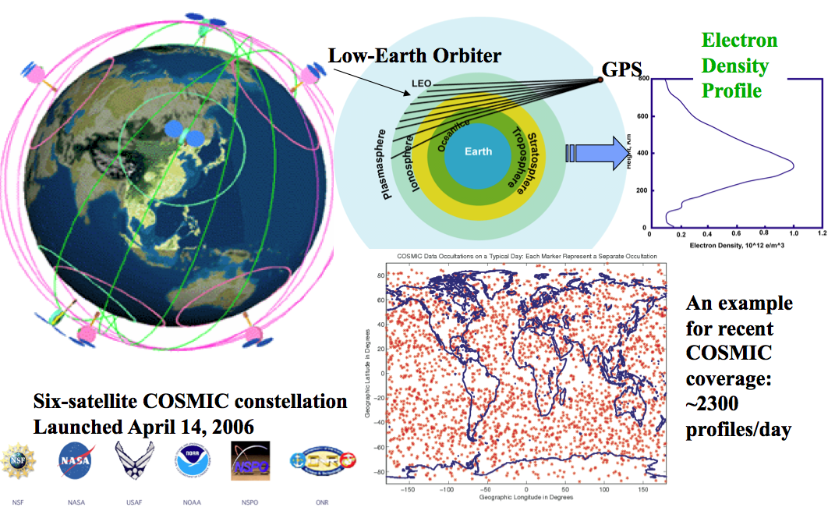
Figure 1. Illustration of the COSMIC concept and constellation.

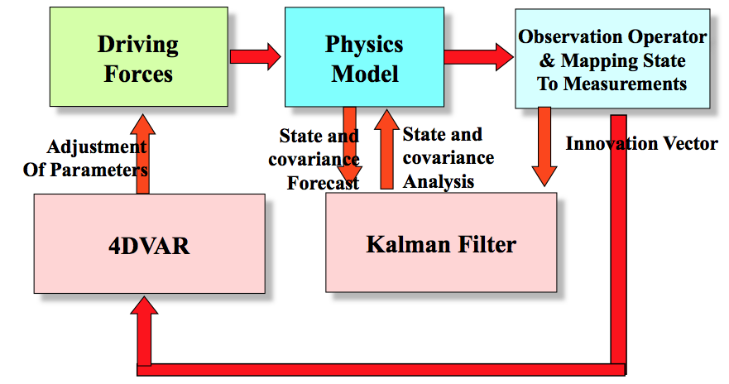

Figure 2. Global Assimilative Ionospheric Model data assimilation modules and process.

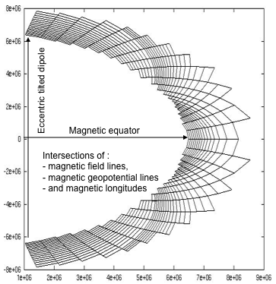
Figure 3. Cross-section at one magnetic longitude of the volume elements used in the GAIM runs.
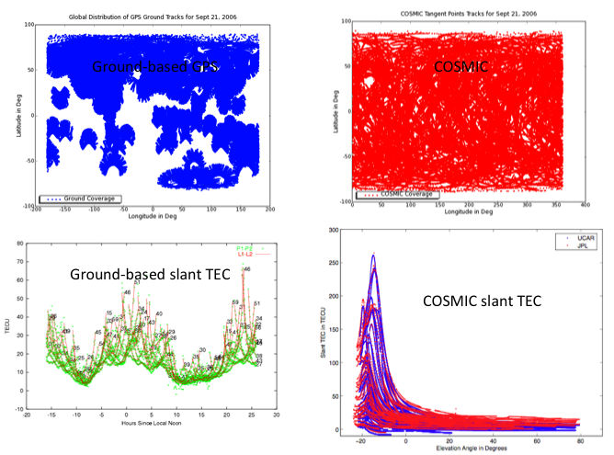
Figure 4. Ground and space-based GPS data sets used in the study
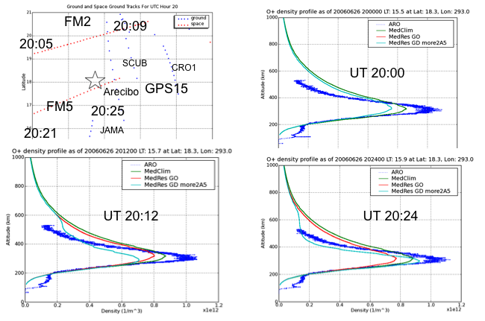
Figure 5. GAIM comparison of GAIM climate (green), ground-only GPS assimilation (red) and ground-GPS plus COSMIC assimilation (blue) with Arecibo ISR data for June 26, 2006.
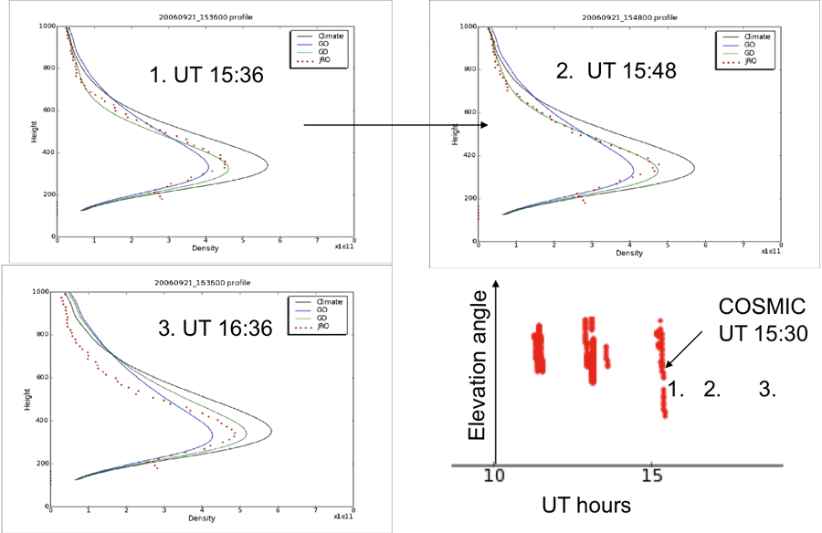
Figure 6. GAIM comparison using ground-based GPS and COSMIC assimilations with Jicamarca ISR on Sept 21, 2006.
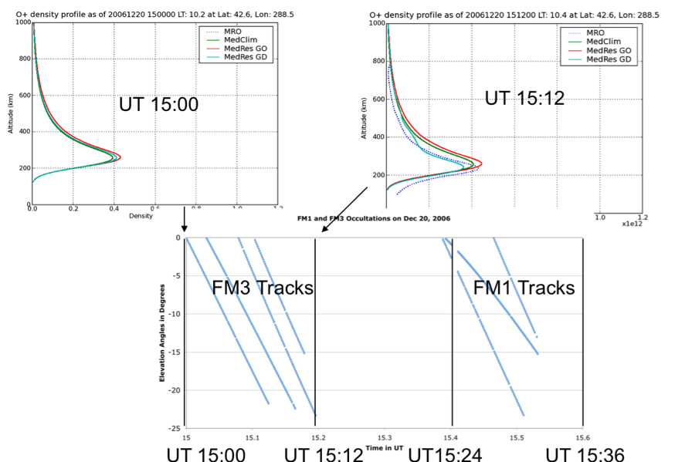

Figure 7. GAIM comparison using ground-based GPS and COSMIC assimilations with Millstone Hill ISR on Dec 20, 2006.

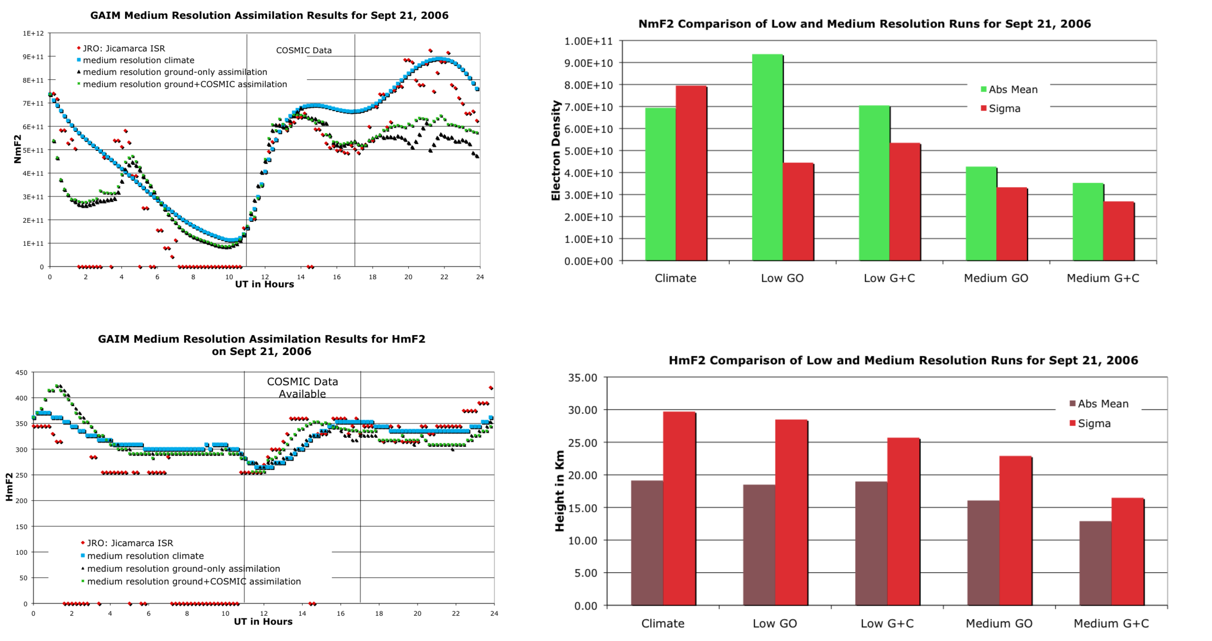
Figure 8. GAIM comparison of NmF2 and HmF2 using ground-based and COSMIC data for low and medium resolution runs.

Figure 9. GAIM comparison of GIM (red), ground GPS data assimilation (black) and ground-GPS plus COSMIC assimilation (magenta) using Jason-2 VTEC measurements.
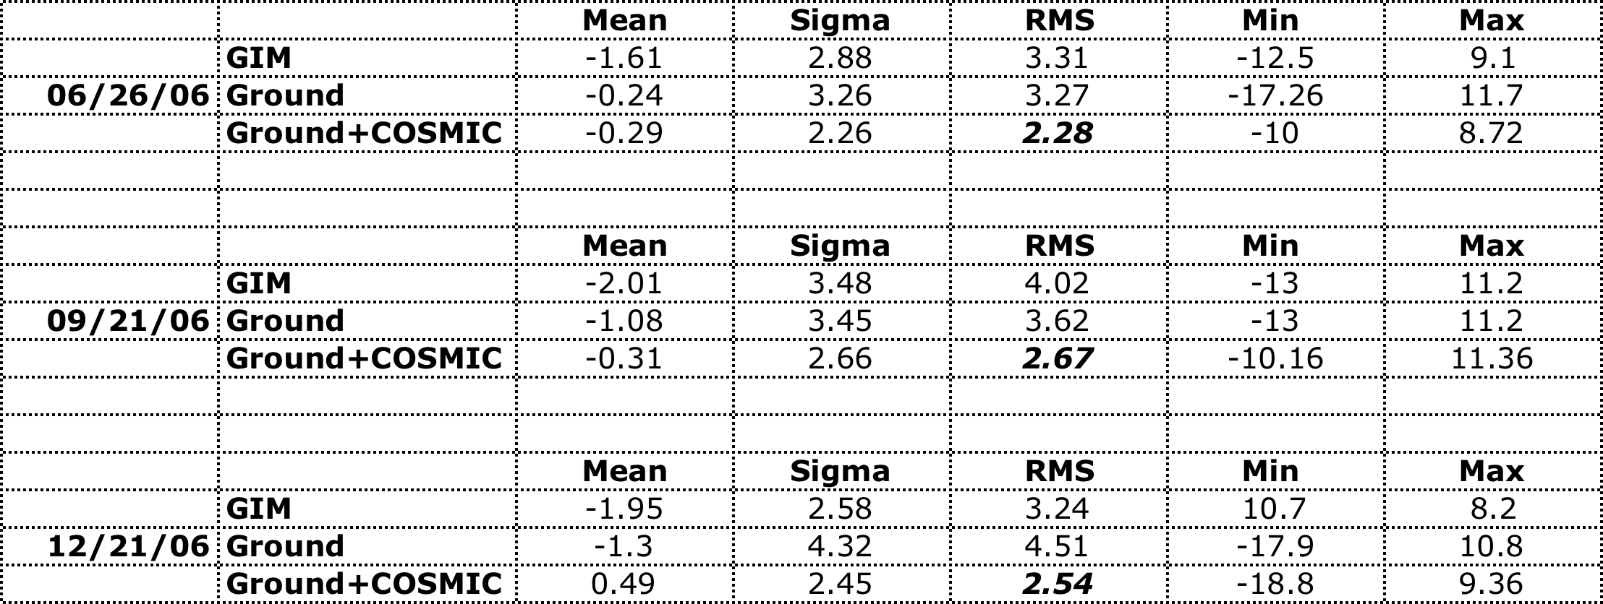
Table 1. GAIM minus JASON VTEC differences for three days using GIM, ground-only-GPS and ground plus COSMIC GAIM assimilation runs.

