x.x.x GAIM Accuracy Validation

To forecast the ionospheric state accurately, one must also “nowcast” accurately. The accuracy of GAIM assimilations and the resulting electron density specifications have been validated in three ways: by a series of simulation experiments in which a known ionospheric density field is used to generate synthetic input data for simulated assimilation runs, by a series of validation case studies using actual input datasets and multiple kinds of validation data, and by continuous validation of daily operational Kalman filter runs beginning in March of 2003.
Simulation. For the simulation experiments, the electron density field and the appropriate values of the drivers (e.g., equatorial ExB vertical drift, neutral winds, and production terms) are known and can be compared to the values estimated by GAIM after input of the synthetic data. For example, we have demonstrated that using only ground GPS TEC links one can gain sufficient information about the shape and location of the equatorial anomaly arcs to estimate ExB vertical drift values as a function of local time and a grid of neutral wind values in geomagnetic coordinates (see Pi et al, 2003 and recent 4DVAR talks available on the GAIM web site).
Validation Cases. For case studies using real input datasets, the true ionospheric state is not known so the accuracy of the electron density specification is evaluated by comparisons to independent ionospheric observations and/or alternative density retrieval techniques. Major validation case studies have been performed for five types or combinations of input data assimilated by GAIM: absolute TEC data from ground GPS receivers (global network), relative TEC data from GPS occultations (flight receivers on IOX, CHAMP, and SAC-C), radiance data from nighttime FUV limb scans (LORAAS instrument on ARGOS), ground GPS TEC combined with GPS occultations, and ground GPS combined with UV limb scans. The combined data runs are particularly relevant to future operational scenarios in which the ground GPS network provides good overall global TEC coverage and dense coverage in some regions, but limited vertical resolution, while GPS occultations from the planned six-satellite COSMIC constellation and UV scans from the SSUSI & SSULI instruments on DMSP provide detailed regional data with excellent vertical resolution.
The accuracy validation studies have included comparisons to: vertical TEC measurements from the TOPEX & JASON dual-frequency ocean altimeters (1330 km altitude), slant TEC measurements from independent GPS sites, FoF2 & HmF2 values or bottom-side profiles from ionosondes, density profiles from incoherent scatter radars, density profiles obtained from Abel inversions of GPS occultations (alternative retrieval technique), and two-dimensional density retrievals (in the plane of the ARGOS satellite orbit) computed by the NRL UV group using Chapman layers. Examples of each of these kinds of validation are documented in the papers and presentations available on the USC/JPL GAIM web site.
Continuous Daily Validation. In order to start accumulating long-term accuracy statistics for GAIM density specification, daily runs of the global Kalman filter were begun in March of 2003. Each day GAIM assimilates more than 200,000 ground GPS TEC observations from 98+ sites to specify the ionospheric density state. The intent is to continuously validate GAIM accuracy as input data types are added (UV radiances or GPS occultations), along with improved drivers from the other operational models. The validation process will be completely automated and performed every day as part of several assimilation runs. Forecast and nowcast accuracy cannot be established by one-time case studies but must be continuously monitored.
Several validation comparisons are already being automated so that accuracy statistics accumulate for every hour and day. They include comparisons to vertical TEC from TOPEX or JASON, comparisons to slant TEC from independent GPS sites that probe a variety of latitude and longitude sectors, and comparisons to FoF2 & HmF2 observations from global ionosonde sites. New JASON data are available every 3-4 hours, and the data from the independent GPS sites are collected either hourly or daily, so accuracy can be monitored every few hours and statistics accumulated daily. The publicly available ionosonde data are delayed but the accuracy of yesterday’s ionospheric specification can be evaluated with a one-day delay, along with the skill score for the 24-hour ionospheric forecast.
As an example of the on-going validation, consider Figure X.X?? which shows a comparison of GAIM results to TOPEX vertical TEC observations on March 12, 2003. Figure X.X??(a) shows the 98 GPS sites used as input for the assimilation and a daytime TOPEX track passing near Hawaii. To perform the comparison, the GAIM density grid is integrated vertically to predict the vertical TEC at the exact location of each TOPEX observation. Figure X.X??(b) compares the measured TOPEX TEC (red + symbols)) to the predicted TEC values from: the GAIM assimilation (blue x’s), the GAIM “climate” (open pink squares, no data input to the model), the IRI95 model (solid turquoise squares), and the two-dimensional TEC maps from the JPL GIM model (green x’s, using the same 98 GPS sites). Note that the GAIM assimilation result follows the two equatorial anomaly peaks quite well, as well as the trough between them and the more gradual mid-latitude gradients. The RMS differences for this track are 4.9 TEC units (10¹⁶ el/m²) for the GAIM assimilation versus 11.3 TECU for the GAIM climate and 12.2 TECU for IRI95.

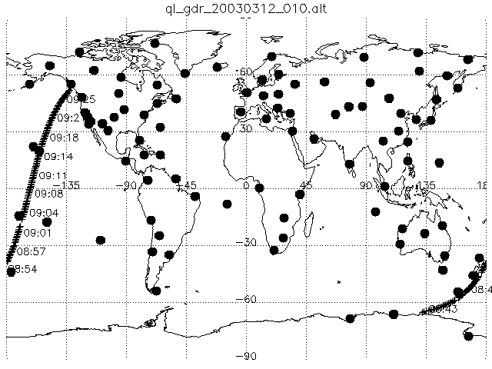

Figure X.X. (a) TOPEX satellite track on March 12, 2003; (b) Comparison of TOPEX vertical TEC observations with four models, TEC versus geographic latitude.

By accumulating the differences (GAIM minus vertical TEC measurements) for all of the TOPEX or JASON tracks each day, one can compute a daily RMS error for the low. mid, and high-latitude regions. (However, note that TOPEX & JASON only probe a fixed local time on any given day). Figure X.Y shows the daily RMS errors for more than half of a year, Mar. 11 to Oct. 17, 2003. Part (a) plots the model RMS errors versus day of year for observations with latitude below 30 degrees, while part (b) shows the RMS error for the mid & high-latitude observations combined. Note that the GAIM assimilation accuracy is quantitatively better than the GAIM climate or IRI95: often 3-7 TECU in the low latitudes and 3-5 TECU in the mid & high latitudes. The variation in the error during the period is a combination of several effects: seasonal dependence of the ionosphere (spring & fall ionosphere levels versus summer), quiet versus disturbed days, and the change in the local time probed by TOPEX.
Figure X.Y. Daily RMS differences (model minus TOPEX) for four models: GAIM Assimilation (open blue squares), GAIM Climate (open pink triangles), IRI95 (solid yellow triangles), and JPL GIM (solid green circles). (a) Low latitudes, (b) Mid & high latitudes combined.

