Status of DORIS stations in Antarctica for precise geodesy

M. Amalvict
Institut de Physique du Globe de Strasbourg / École et Observatoire des Sciences de la Terre, 5 rue René Descartes, 67000, Strasbourg, France, mamalvict@eost.u-strasbg.fr
National Institute of Polar Research, 1-9-10 Kaga, Itabashi-ku, 173 8515, Tokyo, Japan

P. Willis
Institut Géographique National, Direction Technique, 2, avenue Pasteur, BP 68, 94160 Saint-Mandé, France
Jet Propulsion Laboratory, California Institute of Technology, 4800 Oak Grove Drive, Pasadena CA 91109, USA

K. Shibuya
National Institute of Polar Research, 1-9-10 Kaga, Itabashi-ku, 173 8515, Tokyo, Japan

Abstract. Polar regions and especially Antarctica are nowadays recognised as mainly controlling the Mean Sea Level (MSL) directly linked to climate changes. Monitoring and understanding the geodynamical behaviour of these regions is then of critical importance. The long-term displacement (or velocity) of reference sites helps constraining the ice sheet evolution prediction models. Several geodetic space techniques, such as GPS, observe displacements of such reference sites. In Antarctica, besides the quite numerous GPS stations, four DORIS stations are permanently operating: Belgrano, Rothera, Syowa, Terre Adélie. In addition to the permanent DORIS stations, episodic DORIS campaigns took also place at DomeC / Concordia and on Sorsdal and Lambert glaciers. In this paper, we first collect general information concerning the stations and the campaigns (exact location, period of measurements, etc). We then present the results of observations of the permanent stations (vertical and horizontal velocities). In particular, we use several ITRFs (from the early ITRF96 to ITRF2000) to see their impact on the derived velocities in Antarctica. Then we discuss the solutions (when available) obtained by different analysis centres for all DORIS stations, emphasising differences and attempting to explain them. Finally, we compare at these stations, the results of DORIS observations to the solutions from other geodetic techniques (GPS, VLBI) and to the results of repeated absolute gravity measurements (when available).

Keywords., Absolute Gravity, Antarctica, DORIS, GPS, Syowa, Terre Adélie, VLBI

Introduction
Antarctica is a vast area of about 14 million km² of which 98% are covered by an ice cap. The ice volume changes in time; recent studies (Weller, 1998) show that observations in the polar regions are critical to validate climate models which still present large uncertainties. The present-day thawing of ice is one of the reasons of the vertical displacement of a point at the surface of the ice (elastic rebound); horizontal displacements also occur since the thawing is more important at the border of the continent, leading to a flux of ice from inland towards the coast. Because of thawing due to major warming of Antarctica over the past fifty years (Turner et al., 2005), there is an uplift of Mean Sea Level (MSL) due to the increasing amount of water (Cazenave and Nerem, 2004). In fact, things are more complicated because of the moving bedrock. The most important causes of vertical displacements in the Antarctic continent are the Post Glacial rebound (PGR) and the effect of the present Glacial Isostatic Adjustment (GIA). The PGR is the visco-elastic response to the deglaciation, which occurred 11,000 years ago by the end of the last ice age (Peltier, 1996). The GIA is the elastic response of the surface to the present deglaciation. The vertical displacement of the surface can be monitored either by direct or by indirect ways. The direct way is the straightforward observation of the surface; this is the geometrical observation of the surface through classical geodetic techniques such as levelling or satellite positioning. The indirect way uses gravity measurements, a physical data, depending both on the redistribution of masses and on the distance of the station from the Earth’s centre. When no change in mass redistribution is assumed, any variation of in the gravity will lead to a vertical displacement of the site.

Geodetic observations in Antarctica

DORIS observations in Antarctica
DORIS stands for Doppler Orbitography by Radiopositioning Integrated on Satellite; it provides the position of beacons located all over the world, through the observation of the Doppler shift of a signal received by a constellation of up to 6 satellites orbiting around the Earth (Tavernier et al., 2005, http://ids.cls.fr); namely: the satellites of the altimeter missions TOPEX/POSEIDON (only until November 2004), Jason-1 and ENVISAT and the remote sensing satellites SPOT-2, SPOT-4, SPOT-5 and SPOT-3 (only until November 1996). About 55 stations are geographically quite well distributed on the Earth surface. There are however only four permanent DORIS stations in Antarctica (Figure 1): Terre Adélie installed since February 1987, Rothera since November 1991, Syowa since February 1993 and Belgrano that has only been in operation from March 2004 to May 2004 and for which observations started again in summer 2005. In addition to the permanent stations, episodic DORIS campaigns took place at Concordia/DômeC (Vincent et al., 2000) and Sorsdal and Lambert Glaciers (Govind and Valette, 2004).

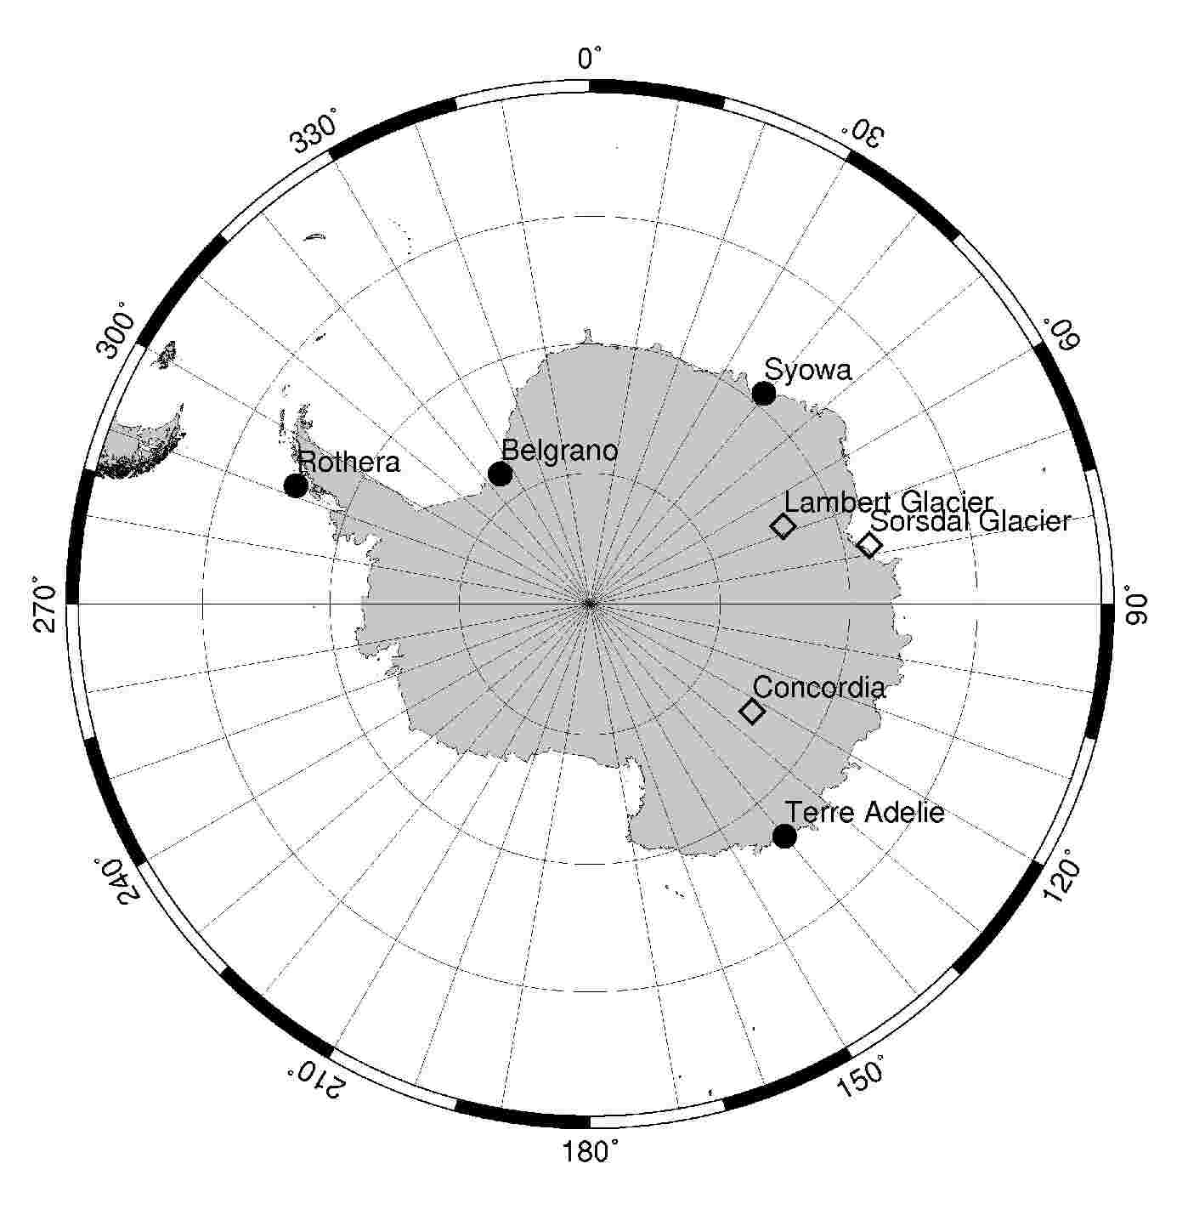

Figure 1. DORIS Antarctic stations. Full circles are for permanent stations, open diamonds stand for episodic campaigns.

The DORIS data of the permanent stations are available at the NASA/CDDIS data centre through the International DORIS Service (IDS), see Tavernier et al., 2005. Table 1 shows the actual period of the DORIS observations available at NASA/CDDIS Data Centre after January 1993, as well as the total number of corresponding IGN/JPL weekly solutions available.
Table 1 shows that the DORIS system provides long-term continuous observations in Antarctica. As it is an up-link system, no data are recorded on site and the ground beacons do not rely on any human intervention or data communication, as it is the case for GPS. In the case of an hostile environment, such as Antarctica, this is a clear logistical advantage.

Site | Name | Start | End | Wks
Terre Adelie | ADEA  ADEB | Jan 93  Mar 02 | Feb 02  Jun 05 | 467  104
Rothera | ROTA  ROTB | Jan 93  Mar 05 | Feb 05  Jun 05 | 574  12
Syowa | SYOB  SYPB | Apr 93  Apr 99 | Apr 98  Jun 05 | 261  319
Belgrano | BELB | Mar 04 | May 04 | 7

Table 1 Summary of DORIS weekly solutions available from the IGN/JPL Analysis Centre at the NASA/CDDIS data centre (July 2005).

More specifically, Figure 2 shows the time series of results available at the CDDIS data centre for the IGN/JPL weekly solutions, showing some temporary interruptions for a few stations. However, in general, continuous observations are available during several years for the same beacon.

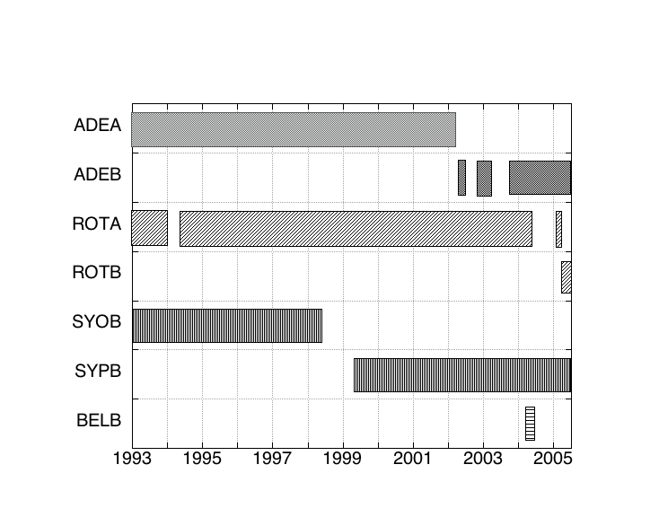

Figure 2. DORIS results available for permanent Antarctic stations at the NASA CDDIS data centre for the IGN/JPL weekly solution IGNWD04 (as July 1, 2005)

In fact, several other IDS Analysis Centres (ACs) process these DORIS data and, for each, several types of solutions are available for DORIS station coordinates:
- cumulative solutions = positions and velocities at a reference epoch, derived from the complete data set of DORIS observations (per AC) and available in SINEX format. These solutions can be directly used for geodesy and geophysics (Soudarin et al., 1999; Crétaux et al., 1998, Willis et al., 2005). These types of DORIS results are available at ftp://cddis.gsfc.nasa.gov/pub/doris/products/sinex_global
- time series of station coordinates = weekly or monthly station coordinates in SINEX format (per AC). These solutions can be obtained either in free-network or loose constrained solution (to be used in future geodetic combinations) or directly projected and transformed into ITRF2000 (Sillard and Boucher, 2001). These solutions correspond to a more recent way to realize the Terrestrial Reference Frame (TRF) through time series of geodetic results instead of using simplified linear model of positions and velocities (Altamimi et al., 2005). These types of DORIS results are available at ftp://cddis.gsfc.nasa.gov/pub/doris/products/sinex_series
- station coordinate differences = station coordinates expressed in ITRF2000 for weekly or monthly solutions in STCD format (STation Coordinate Difference), see Tavernier et al., 2005. This format proposes a more user-friendly presentation (tabulated in XYZ and in North/East/Vertical results) of time series results for a potentially broader community of users. These DORIS results are available at ftp://cddis.gsfc.nasa.gov/pub/doris/products/stcd
From all ACs, only IGN/JPL currently provides all types of results and process them in timely manner (new results are posted at CDDIS every week or so within 1 day after data delivery). In the future, it is expected that more ACs would provide similar solutions and that a combined DORIS solution would be available as well (Feissel-Vernier et al., 2005).
Figure 3 shows an example of plots of time series available at IDS website. It can be noticed that the precision is improving in the last years.

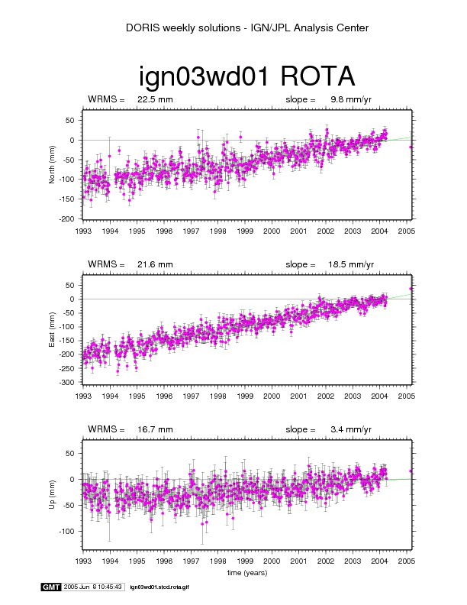 | 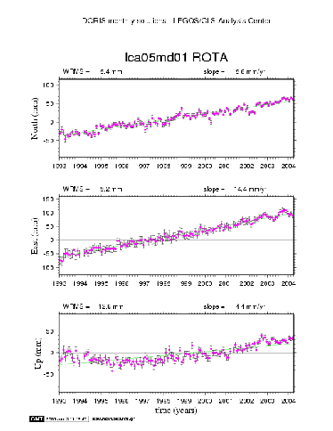

Figure 3: Doris weekly and monthly time series, at Rothera, from IDS Web site. For the vertical component, + is up and – is down

On Figure 3, results from the LEGOS/CLS groups are much smoother as they are based on monthly solutions, while results from the IGN/JPL group are based on weekly solutions, hence providing more data (this could be an advantage for outlier detection). Both DORIS solutions are in good agreement. These results are regularly updated on Internet: every 3-6 month for LEGOS/CLS and every week for IGN/JPL.
It must also be noted that the precision of these DORIS geodetic results strongly depends on the number of available DORIS satellites (Willis et al., 2005), varying between 2 to 5 from 1993 to 2005. Due to ENVISAT and SPOT5, the results have a better precision after March 2002, as they are based on data from 4 or 5 satellites instead of 2 in the early 1993 solutions. We also need to point out here that unfortunately the DORIS/Jason data cannot be used for geodesy due to an extreme sensitivity to radiation affecting the satellite oscillator over the South Atlantic Anomaly (Willis et al., 2004).
Finally, satellites with quai-polar satellites, such as SPOTs and ENVISAT, provide more DORIS data in the polar region and are critical for positioning accuracy.

Other positioning techniques

GPS
The International GPS Service (IGS), see Beutler et al., 1999, includes 7 permanent stations in Antarctica, namely Syowa since 1999, Mawson since 1999, Davis since 1995, Casey since 1995, McMurdo since 1995, O’Higgins since 1995 and Sanae IV since 1999. Out of these, only Syowa is equipped with a DORIS beacon. There are numerous studies based on GPS observations to analyse the horizontal and deformations in Antarctica(James and Ivins, 1998; Larson and Freymueller, 1995; Bouin and Vigny, 2000). In addition to the IGS stations, several permanent GPS receivers are also installed in Antarctica. This is the case at Terre Adélie since 1998 and at Rothera since 1998. Bouin and Vigny (2000) published the results of the Terre Adélie station, which belongs to a specific geophysical network of the ENS (École Normale Supérieure). In addition to these permanent stations, episodic campaigns are also organised, mostly during austral summer. Dietrich et al. (2001) derived horizontal motions from GPS data of 1992 to 1998 campaigns organised by the Scientific Committee on Antarctic Research (SCAR). In addition, specific experiments are also organised during the austral summer season (Tregoning et al., 2000).

VLBI
There are 2 VLBI stations in Antarctica: Syowa (11 m antenna) and O’Higgins (9 m antenna) in the Antarctic Peninsula; DORIS is collocated at Syowa. Fukuzaki et al. (2005) analysed VLBI sessions connecting Syowa to 3 other stations in Antarctica, Australia and Africa. VLIBI velocity results were derived for the Syowa station and compared to earlier GPS and DORIS determinations.

Physical geodesy in Antarctica

Opposite to data from space geodesy techniques, absolute gravity measurements are only given episodically. They typically last a few days, averaging results of thousands of drops of a free-falling body in the vacuum chamber of the gravimeter. The measurements should be ideally repeated every couple of years, which is quite challenging in this region. The gravity changes (if any) are then interpreted as changes in mass redistribution and/or changes in height of the station itslef. The 23 Absolute Gravimetry (AG) measurements in Antarctica, obtained at 12 different stations are listed and analysed by Amalvict et al. (2005). Among them, the only 2 DORIS stations are Terre Adélie and Syowa. Syowa is the only DORIS station with repeated AG measurements: 7 measurements between 1992 and 2004.

Models and predictions

Changes in MSL and Ice Mass in Antarctica are key parameters for understanding ‘Global Change’. Numerous models are attempting to depict of the station displacements and velocities. Prediction models are depending on physical parameters, inferred from observations: viscosity, timing of glaciation and deglaciation.

The PGR, resulting of the deglaciation started more than 10 000 years ago, involves a long period of time. The rheology of the Earth is then visco-elastic. On the contrary, the GIA, which is the response of the Earth surface to the present-day deglaciation does not involve time, due to its elastic behaviour. Observations are affected by these phenomena (and of several others) and models can help separating these phenomena.
Among the models, we can mention Peltier (1996), James and Ivins (1998), Nakada et al. (2000). These models, relying on different glaciation and deglaciation models predict vertical displacements (and sometimes gravity changes). A rapid overview of this problem, in Antarctica, is given in Amalvict et al. (2005).
The value of the ratio dg/dh derived from observations of both changes in gravity g and changes in height h can help in constraining the physical parameters of rebound models (Wahr et al., 1995).

Results and discussion
We focus on vertical velocities, which is indeed the component involved in PGR and GIA previously described. This is also the component directly derived from the gravity variations.

- DORIS analysis
We have analyzed here available DORIS station velocities derived by different groups (Table 2).
First we have considered the latest ITRF solutions: ITRF96 (Sillard et al., 1998), ITRF97 (Boucher et al., 1998) and ITRF2000 (Altamimi et al., 2002). They all provide positions and velocities based on a global adjustment of several DORIS individual solutions as well as other individual solutions from other techniques (VLBI, SLR and GPS) and geodetic local ties properly weighted. Continuous improvement in the adjustment method has been done between these three realizations as well as in the pre-processing (data screening). In the future, a new ITRF2005 should be available soon, combining time series of results instead of cumulative solutions (positions and velocities at a reference epoch) as proposed by Altamimi et al., 2005.

Solution | Source | Type | Last data
ITRF96 | IERS | X/V | Jul 97
ITRF97 | IERS | X/V | Dec 97
ITRF2000 | IERS | X/V | Mar 99
IGN03D02 | IGN/JPL | X/V | Dec 03
IGN04D02 | IGN/JPL | X/V | Sep 04
IGN05D02P | IGN/JPL | X/V | Jun 05
STCD_IGN | IGN/JPL | week | Jun 05
STCD_LCA | LEGOS/CLS | month | Jan 05

Table 2 DORIS results analyzed to derive vertical velocities for DORIS stations in Antarctica (June 2005). X=position, V=velocity, week=weekly solution, month=monthly solution.

We have also considered three recent DORIS solutions from the IGN/JPL DORIS Analysis Center: IGN03D02 (Willis et al., 2005), IGN04D02 (Willis and Heflin, 2004) and a preliminary solution for IGN05D02P, based on the same DORIS analysis strategy but using more DORIS data (Table 1) as well as a refined pre-processing (data screening and also identification of station coordinates discontinuities as described in Willis and Ries, 2005). These three solutions are also cumulative solutions (positions/velocities) but they only take into account DORIS results from the IGN/JPL Analysis Centre as well as DORIS-DORIS geodetic local ties, with proper constrain, when a new DORIS beacon is installed in close collocation with an older DORIS instrument. Results from other techniques or from other groups are not used in this study.
As a test, we have also analyzed two new types of solutions, provided as time series of results expressed in ITRF2000 in the STCD format (STation Coordinate Differences). We have considered here the latest LEGOS/CLS (LCA) monthly solutions and the IGN/JPL (IGN) weekly solutions as they are regularly updated by these groups and available at NASA/CDDIS through the IDS (Tavernier et al., 2005). These results are available per station (there are potentially several DORIS beacons at the same site, corresponding to successive instrument occupations) and for each solution we derived a weighted slope using the available data on July 2005.

Source | acronym | V  (mm/yr) | Sig V  (mm/yr)
ITRF96 | ADEA | -5.90 | 6.56
ITRF97 | ADEA | 0.93 | 4.05
ITRF2000 | ADEA | -0.86 | 1.39
IGN03D02 | ADEA/ADEB | -1.10 | 0.16
IGN04D02 | ADEA/ADEB | 0.47 | 0.16
IGN05D02P | ADEA/ADEB | 0.63 | 0.15
STCD_IGN | ADEA  ADEB | -0.01  8.04 | 0.19  0.88
STCD_LCA | ADEA  ADEB | 1.37  4.43 | 0.16  1.31

Table 3 DORIS vertical velocities estimated for Terre Adelie

In Table 3, the constant decrease of the formal errors between ITRF96, ITRF97 and ITRF2000 shows the continuous improvement made by the IERS in the global combination. A similar trend can also be seen in parallel in the three consecutive IGN/JPL solutions. However, the improvement is much smaller because it only corresponds to an increase in the considered DORIS observation data span (the DORIS analysis strategy was exactly the same). The IGN/JPL also provides much smaller formal errors than ITRF solutions. This can come from a different re-weighting of the solutions and also from current systematic errors in the different IERS techniques. Finally, the STCD approach provides less precise results because the DORIS-DORIS local tie information was not used, so all the DORIS results and information (local ties) were not used when more than one DORIS beacon exists at the DORIS site.

Source | acronym | V  (mm/yr) | Sig V  (mm/yr)
ITRF96 | ROTA | -5.40 | 8.32
ITRF97 | ROTA | 3.54 | 5.29
ITRF2000 | ROTA | 1.27 | 1.95
IGN03D02 | ROTA | 1.95 | 0.14
IGN04D02 | ROTA | 3.71 | 0.13
IGN05D02P | ROTA/ROTB  ROTA(*) | 1.53  4.78 | 0.56  0.20
STCD_IGN | ROTA  ROTB | 3.93  -92.07 | 0.13  34.25
STCD_LCA | ROTA  ROTB | 5.25  - | 0.12  -

Table 4 DORIS vertical velocities estimated for Rothera

In table 4 (Rothera) and Table 5 (Syowa) we observe the same decrease of formal errors than in Table 3. In the case of Rothera, the new beacon ROTB is too recent to provide any valuable information on the velocity using the STCD solution. However, it is also possible to use the ROTA and ROTB STCD solutions, as well as the DORIS-DORIS local tie information to provide a longer time series better suited for velocity determination. In this case, the local time precision is assumed to be at 1 mm and does not degrade the precision of this technique.

Source | acronym | V  (mm/yr) | Sig V  (mm/yr)
ITRF96 | SYOB | 2.14 | 8.58
ITRF97 | SYOB | 5.89 | 5.06
ITRF2000 | SYOB/SYPB | 2.11 | 1.89
IGN03D02 | SYOB/SYPB | 1.81 | 0.25
IGN04D02 | SYOB/SYPB | 3.61 | 0.21
IGN05D02P | SYOB/SYPB | 3.89 | 0.19
STCD_IGN | SYOB  SYPB | 4.04  3.50 | 0.49  0.28
STCD_LCA | SYOB  SYPB | 0.17  6.40 | 0.44  0.26

Table 5 DORIS vertical velocities estimated for Syowa

In the case of the Syowa stations, all DORIS estimations show a clear positive and small vertical uplift of the station.

In the case of the Belgrano station, the DORIS results are only based on 7 weeks of data and are currently rather useless for any geodetic or geophysical investigation (Table 6).

Source | acronym | V  (mm/yr) | Sig V  (mm/yr)
ITRF96 | - | N/A | N/A
ITRF97 | - | N/A | N/A
ITRF2000 | - | N/A | N/A
IGN03D02 | - | N/A | N/A
IGN04D02 | BELB | -75.78 | 17.04
IGN05D02P | BELB | -22.2 | 30
STCD_IGN | BELB | -171.43 | 83.74
STCD_LCA | BELB | 206.49 | 187.37

Table 6 DORIS vertical velocities estimated for Belgrano

The station does not even appear in the earlier DORIS TRFs. However, more recently, after an interruption of more than a year, a new station (BEMB) has been installed and should provide soon some regular data to the NASA/CDDIS IDS Data Centre. The velocity calculated by August 6 is -22.2 ± 30 mm/yr but the velocity estimation should then rapidly improve as soon as more data become available (a geodetic local tie is provided by IGN/SIMB between BELB and BEMB with a precision of 2 mm).

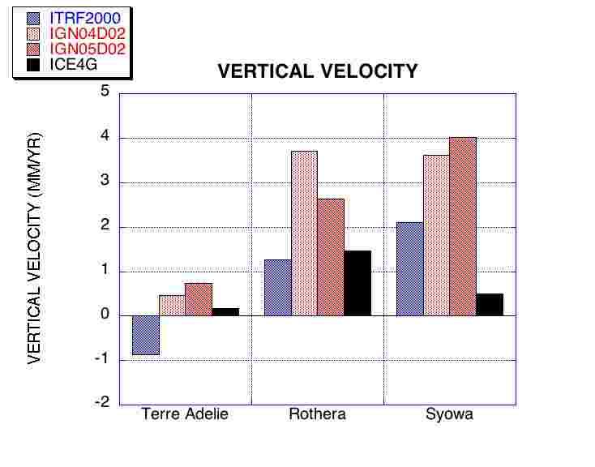
Figure 4: Vertical velocities in Antacrtica (observations and predictions)

Figure 4 shows the vertical velocities at the 3 stations, according to different models. Figure 5 shows the same result for horizontal velocities. We notice again than ITRF2000 leads to slightly different results. The IGN/JPL cumulative solutions based on the same DORIS processing strategy provides closer results. All results differ from ICE-4G models at a few mm/yr, especially in Syowa.
Figure 5 shows the agreement between the estimated DORIS horizontal velocities and a plate motion model GSRM 1.2, see Kreemer et al., 2003. All results are in good agreement within a couple of mm/yr.

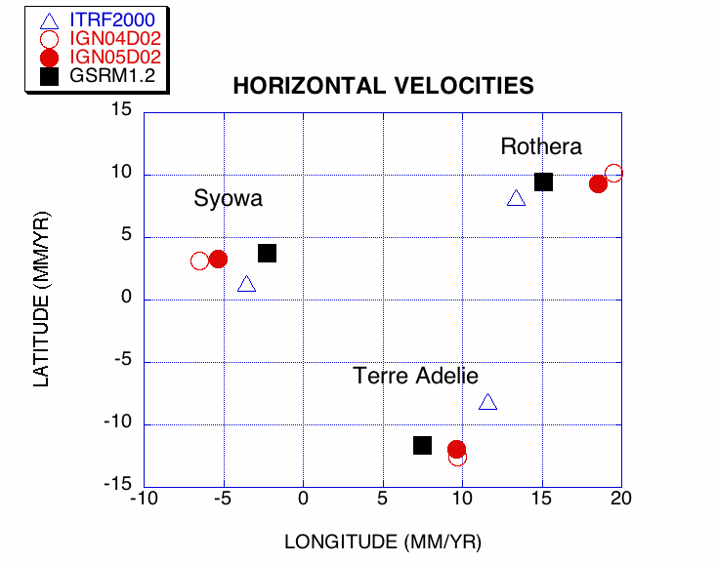

Figure 5: Horizontal velocities in Antarctica (models and prediction)

We can notice that the precision is as high for the vertical velocity than for the horizontal one.

- GPS analysis
Fukuzaki et al. (2005) obtain 2.26 ± 0.33 mm/yr at Syowa for the vertical displacement. The daily JPL GPS results, available on-line at http://sideshow.jpl.nasa.gov/mbh/series.html provide an estimate with opposite sign 2.53 mm/yr ± 0.27. These GPS/JPL results are based on a Precise Point Positioning technique (Zumberge et al., 1997). Terre Adélie is not an IGS station; the value of the vertical velocity is 0.43 ± 1.5 mm/yr according to the TIGA analysis and – 0.56 ± 2 according to M.N. Bouin’s analysis (personal communication).

- VLBI analysis
Fukuzaki et al. (2005) report on VLBI measurements at Syowa from 1999 to the end of 2003. They obtain 4.6 ± 2.2 mm/yr for the vertical component of velocity.

- AG analysis
Amalvict et al., 2005 follow the analysis of Fukuda et al. (2004) at Syowa station, leading to a change of gravity equal to – 0.3 ± 0.4 µGal/yr.

- Comparison of results from different techniques

 | Syowa | Terre Adélie | Rothera
DORIS mm/yr | 3.6 ± 0.2 | 0.63 ± 0.15 | 1.53 ± 0.56
GPS mm/yr | 2.3 ± 0.3 | 0.43 ± 1.5  -0.56 ± 2 | -8.5 ± 2.0
VLBI mm/yr | 4.6 ± 2.2 | N/A | N/A
AG µGal/yr | -0.3 ± 0.43 | N/A | N/A
Prediction | ~ 0 | ~ 0

Table 7 Comparison of vertical velocities at different DORIS stations. Syowa: GPS and VLBI results from Fukuzaki et al., 2005; DORIS results, IGN04D02 solution. Terre Adélie: GPS results from TIGA and MN Bouin, 2005; DORIS results, IGN04D02 solution. The value of the GPS vertical velocity at the Rothera station comes from http://itrf.ensg.ign.fr/ITRF_solutions/2000/results/ITRF2000_SCAR.SSC.txt, is rather different from DORIS but the standard deviation makes it compatible with the DORIS results. It is highly possible that only a few GPS data were used to derive this GPS velocity (short time series). Future solutions should confirm or infirm our DORIS results.
The agreement between different positioning techniques is fairly good at Syowa; the results are consistent with both AG trend and modelled predictions. At Terre Adélie, the 2 GPS solutions can be seen as a non-significant displacement, which is in agreement with the modelled prediction. DORIS solution for Terre Adelie is consistent with a very small displacement.

Looking at horizontal velocities at Syowa, we have:

Syowa | East | North
DORIS mm/yr | -6.5 ± 0.8 | 3.2 ± 0.9
GPS mm/yr | -4.4 ± 0.2 | -0.2 ± 0.2
VLBI mm/yr | -2.5 ± 0.6 | 4.0 ± 0.7

Table 8 Comparison of horizontal velocities at Syowa station; GPS and VLBI results from Fukuzaki et al., 2005; DORIS results, IGN04D02 solution.

In our opinion, the difference in periods of observations could, partly, explain the differences in results.

Conclusions

The present analysis of DORIS data at Antarctic stations shows the sensitivity of the solution to the models (Earth model, data sampling…). Comparison of different positioning techniques at the same station shows a fairly good agreement for vertical velocities (typically 1-2 mm/yr). There is only one station (Syowa) with repeated Absolute Gravimetry measurements, showing good agreement. DORIS proves to be a useful geodetic tool, especially as it provides long-term and continuous measurements in this hostile environment. It is also quite encouraging to see that the most recent results (since 2002) provide far better geodetic precision. It is then important that the number of polar satellites carrying a DORIS receiver remains the same, or even increases, to obtain good geodetic results in the future.
In conclusion, we should say that the number of DORIS beacons should be increased in Antarctica. There is now such a possibility as the new satellite receiver allow measurements from shifted frequency transmission from ground station, decreasing possible interferences on-board the satellite and allowing a larger number of DORIS beacons in the same region of the world. We do hope that the coming IPY (International Polar Year) will give a boost in that direction.

Acknowledgments. This study was carried out during the stay of MA at the National Institute for Polar Research (NIPR), Tokyo, Japan under a fellowship from the Japanese Society for the Promotion of Science (JSPS). Part of this research was carried out at the Jet Propulsion Laboratory, California Institute of Technology, under a contract with the National Aeronautics and Space Administration (NASA). Authors thank MN Bouin who provided her GPS results for Terre Adélie and K. Doi who draw the map of Antarctic DORIS stations.

References

Altamimi Z., P. Sillard, C. Boucher (2002). ITRF2000, A new release of the International Terrestrial Reference Frame for earth science applications, Journal of Geophysical Research, Solid Earth, Vol. 107(B10), pp. 2214.
Altamimi Z., C. Boucher, P. Willis (2005). Terrestrial Reference Frame requirements within GGOS, Journal of Geodynamics. Vol. 40(4-5), pp. 363-374

Amalvict M., Mäkinen J., Shibuya K. and Fukuda Y., 2005, Absolute Gravimetry in Antarctica: Status and Prospects, Journal of Geodynamics, submitted
Beutler G., M. Rothcaher, S. Schaer, T.A. Springer, J. Kouba, R.E. Neilan (1999), The International GPS Service (IGS), an interdisciplinary service in support of Earth sciences, Advances in Space Research, Vol. 23(4), pp. 631-653.
Bouin MN, Vigny C (2000), New constraints on Antarctic plate motion and deformation from GPS data, Journal of Geophysical Research, Solid Earth, Vol. 105(B12), pp. 28279-28293.
Boucher C., Z. Altamimi, and P. Sillard (1998), The 1997 International Terrestrial Reference Frame (ITRF97), IERS Techn. Note 27, Paris Observatory.
Bouin M.N., 2005, personal communication
Bouin M.N. and Vigny C., 2000, New constraints on Antarctic plate motion deformation and deformation from GPS data, Journal of Geophysical Research Solid Earth, Vol. 105(B12), pp. 28279-28293.
Cazenave A., Nerem R.S. (2004). Present-day sea level change, Observations and causes, Reviews of Geophysics, Vol. 42(3), RG3001
Crétaux J.F., L. Soudarin, A. Cazenave, F. Bouille (1998). Present-day Tectonic Plate Motions and Crustal Deformations from the DORIS Space System, Journal of Geophysical Research, Solid Earth, Vol. 103(B12), pp. 30167-30181
Dietrich R, Dach R, Engelhardt G, Ihde J, Korth W, Kutterer H-J, Lindner K, Mayer M, Menge F, Miller C, Niemeier W, Perlt J, Pohl M, Salbach H, Schenke H-W, Schöne T, Seeber G, Veit A, Völksen C, 2001, ITRF coordinates and plate velocities from repeated GPS campaign in Antarctica—an analysis based on different individual solutions. Journal of Geodesy, Vol. 74(11-12), pp. 756–766
Feissel-Vernier M., Valette J.J., Soudarin L., Le Bail K. (2005). Report of the 2003 Analysis campaign “Impact of GRACE gravity field models on IDS products”, IDS Report.
Fukuda Y, Higashi T, Takemoto S, Iwano S, Doi K, Shibuya K, Hiraoka Y, Kimura I, McQueen H, Govind R., 2004, Absolute gravity measurements in Australia and Syowa Station, Antarctica. GGSM2004, Porto (Portugal), submitted
Fukuzaki Y., Shibuya K., Doi K., Ozawa T., Nothnagel A., Jike T., Iwano S., Jauncey D. L., Nicolson G. D., McCulloch P. M. (2005). Results of the VLBI experiments conducted with Syowa Station, Antarctica, Journal of Geodesy, Vol. 79(6-7), pp. 379-388.
Govind et Valette, 2004, The Sordsal and Lambert campaigns : organisational aspects and first results, IDS 2004 Plenary Meeting, http://lareg.ensg.ign.fr/IDS/events/prog_2004.html
James T.S., E.R. Ivins (1998). Predictions of crustal motions driven by present-day ice sheet evolution and by isostatic memory of the Last Glacial Maximum, Journal of Geophysical Research, Solid Earth, Vol. 103(B3), pp. 4993-5017.
Kreemer C., W.E. Holt, A.J. Haines (2003). An integrated global model of present-day plate motions and plate boundary deformation, Geophysical Journal International, Vol. 154(1), pp. 8-34.
Larson K, Freymueller J (1995), Relative motions of the Australia, Pacific and Antarctic plates by the Global Positioning System. Geophysical Research Letters, Vol. 22(1), pp. 37-40.
Nakada M, Kimura R, Okuno J, Moriwaki K, Miura H, Maemoku H, 2000, Late Pleistocene and Holocene melting history of the Antarctic ice sheet derived from sea-level variations, Marine Geology, Vol. 167, pp. 85–103.
Peltier W.R. (1996). Mantle viscosity and ice-age ice sheet topography, Science, Vol. 273(5280), pp. 1359-1364.
Sillard P., Z. Altamimi, and C. Boucher (1998). The ITRF96 realization and its associated velocity field, Geophysical Research Letters, Vol. 25(17), pp. 3223-3226.
Sillard P., and C. Boucher (2001). A review of algebraic constraints in Terrestrial Reference Frame datum definition, Journal of Geodesy, Vol. 75(2-3), pp. 63-73.
Soudarin L., J.F. Crétaux, A. Cazenave (1999). Vertical Crustal Motions from the DORIS space-geodesy system, Geophysical Research Letters, Vol. 26(9), pp. 1207-1210.
Tavernier G., H. Fagard, M. Feissel-Vernier, F. Lemoine, C. Noll, J.C. Ries, L. Soudarin, P. Willis (2005). The International DORIS Service, IDS, Advances in Space Research, Vol. 36(3), pp. 333-341.
Tregoning, P., A. Welsh, H. McQueen and K. Lambeck, 2000, The search for postglacial rebound near the Lambert Glacier, Antarctica Earth, Planets and Space, Vol. 52(11), pp. 1037-1041
Turner J., Colwell S.R., Marshall G.J., Lachlan-Cope T.A., Carleton A.M., Jones P.D., Lagun V., Reid P.A., Iagovkina S. (2005). Antarctic climate change during the last 50 years, International Journal of Climatology, Vol. 25(3), pp. 279-294
Vincent C., J.J. Valette, L. Soudarin, J.F. Cretaux, B. Legresy, F. Remy, A. Capra (2000). DORIS campaigns at Dome Concordia, Antarctica in 1993 and 1999-2000, in Proc. DORIS Day 2000, CNES, France.
Wahr J, Han D, Trupin A, (1995) Predictions of vertical uplift caused by changing polar ice volumes on a viscoelastic Earth. Geophysical Research Letters, Vol. 22(8), pp. 977–980.
Weller G. (1998). Regional impacts of climate change in the Arctic and Antarctic, Annals of Glaciology, Vol. 27, pp. 543-552
Willis P., M. Heflin (2004). External validation of the GRACE gravity GGM01C gravity field using GPS and DORIS positioning results. Geophysical Research Letters, Vol. 31(13), L13616
Willis P., J.C. Ries (2005), Defining a DORIS core network for Jason-1 precise orbit determination based on ITRF2000, Methods and realization, Journal of Geodesy, Vol. 79(6-7), pp. 370-378.
Willis P., B. Haines, J.P. Berthias, P. Sengenes, J.L. Le Mouel (2004). Behavior of the DORIS/Jason oscillator over the South Atlantic Anomaly, Comptes Rendus Geoscience, Vol. 336(9), pp. 839-846.
Willis P., C. Boucher, H. Fagard, Z. Altamimi (2005), Geodetic applications of the DORIS system at the French Institut Géographique National, Comptes Rendus Geoscience, Vol. 337(7), pp. 653-662.
Zumberge J.F., M.B. Heflin, D.C. Jefferson, M.M. Watkins, F.H. Webb (1997). Precise point positioning for the efficient and robust analysis of GPS data from large networks, Journal of Geophysical Research, Solid Earth, Vol. 102(B3), pp. 5005-5017.

