20 years of evolution for the DORIS permanent network:
From its initial deployment to its renovation

Hervé FAGARD¹

¹ Institut Géographique National, Service de Géodésie et Nivellement, 94160 Saint-Mandé, France.
Fax : + 33 1 43 98 84 50, e-mail : herve.fagard@ign.fr

Abstract

Keywords DORIS, tracking network, geodesy, reference frames
1 INTRODUCTION : HISTORICAL BACKGROUND

The realization of the DORIS system was decided jointly in the early eighties by the French space agency (CNES: Centre National d’Études Spatiales), the French national mapping agency (IGN-F: Institut Géographique National – France) and a research group in the field of space geodesy (GRGS: Groupe de Recherche en Géodésie Spatiale). Since then, the DORIS system has evolved into a larger international cooperation, leading to the recent establishement of the International DORIS Service (IDS), see Tavernier et al. 2005. Because of its experience in the field of the installation of geodetic networks, IGN has taken care of the deployment of the ground network and of the determination and publication of the stations coordinates (Willis et al. 2005). For twenty years now, the geodetic department of IGN-F (SGN: Service de Géodésie et Nivellement) has been negotiating agreements with host agencies, installing the equipment, surveying the antennas, and keeping the DORIS stations in working condition.

An essential requirement for the precise computation of the orbits was to ensure an almost constant visibility of at least one ground station by the on-board receiver. On the other hand, to be able to express the orbit in a precise terrestrial reference system, the coordinates of a sufficient number of well-distributed stations had to be available in the same system. To meet the orbit coverage requirement for the SPOT-2 satellite (830 km altitude), it was estimated that the network should be made of approximately 50 stations, as evenly distributed as possible around the globe.

In this paper we will be relating… À COMPLÉTER

2 THE STEPS OF A DORIS STATION INSTALLATION

2.1 Sites selection criteria.

The initial list of potential DORIS stations locations mainly ensued from the need of geocentric coordinates, the best source of which would be a co-location of the DORIS antenna with the space geodesy techniques available at that time: Very Long Baseline Interferometry (VLBI) and Satellite Laser Ranging (SLR). When none of these instruments were available, coordinates could be obtained through Doppler Transit or GPS positioning, either already determined in the frame of international measurement campaigns or to be measured by IGN at the same time as the DORIS equipment installation. This was notably the case at many islands primarly selected to meet the density and homogeneous distribution criteria for the network, even though no space geodesy measurements had ever been performed at these sites.

The concern for co-locations between the DORIS stations and tide gauges appeared later, with the growing interest for sea level rise related studies (Douglas 1991; Nerem et al. 1997; Cabanes et al. 2001).

2.2 Selection of a host agency.

After a site had been a priori selected, a host agency had to be found, who would agree to host the station and take care of its maintenance, and where the following needs could be met :
- The transmitting beacon and its backup power supply needed to be in a room with moderate temperature and temperature gradient, with mains power supply available.
- The antenna had to be installed outside with a clear view above 10 degrees, on a structure that would allow the use of antenna supports – guyed tower or wall side mount – used at that time.
- It was necessary to check that the frequencies transmitted by DORIS would not be likely to interfere with existing receivers in the area, and the necessary frequency clearance had to be obtained.
- The host agency should agree to carry out some occasional maintenance operations at IGN’s request. This would include some minor verifications and adjustments, as well as sending out of order equipment for repair.

In order to check that the prospective host agency would match the above requirements, a questionnaire was sent which generally resulted in yes/no answers to a few questions, and a variable amount of details about the site layout. This has been progressively evolving throughout the network’s deployment, with a deeper and deeper preliminary survey being conducted as the requirements for antenna stability became more stringent (see Chapter ?).

Then it was necessary to obtain the prospective host agency’s agreement to host and maintain the DORIS station, which was in some cases materialized by a written agreement signed with IGN. Frequency clearance had also to be granted, which was generally handled by the host agency through an application with the relevant radio communications authorities. This negotiation stage generally took several months, but some projects – especially in the recent years, after all the “easy” ones had been achieved in the first years – took up to two or three years in succeeding.

2.3 Installation stage.

Once a host agency had been found and all the necessary authorizations granted, the installation was performed by IGN. This stage included :
- Dispatch and customs clearance of the equipment.
- Installation and starting up of the station.
- Training of the staff who would take care of the maintenance.
- Geodetic survey of the antenna’s reference point, and connection to another space geodesy technique, or to the local geodetic network.

3 IDENTIFICATION OF THE DORIS SITE AND POINTS

Each DORIS site (i.e. a location hosting a DORIS station, where several successive DORIS points may have been present) is identified by its name. This name can be:
- The name of the “space geodesy site” – especially in the early days of the network deployment – which is some cases was very large (up to 30 km). For example, the so-called “Libreville” station is in fact located at N’Koltang, ?? km away from Libreville.
- The name of the city where the station is located, or the name of a nearby major city.
- The name of the island where the station is located.

In a few cases, the chosen site name turned out later not to be a very wise one. For example, “Galapagos” is the name of an archipelago made ten or so islands, extending over 300 km. Therefore a more accurate name (Santa Cruz, i.e. the name of the island) was chosen when a new station was installed in March 2005, in order to avoid confusion with the first station installed at Sán Cristobal island, inaccurately named “Galapagos”.

Each DORIS point (i.e. each location of a DORIS antenna reference point) is identified by:
- A DOMES number (e.g. 10202S003 for the current DORIS antenna at Reykjavik).
- A four character ID or acronym, built as follows:
  - The first three characters are derived from the site name (e.g. La Réunion → REU, Cibinong → CIB, Ponta Delgada → PDL, etc.).
  - The last character identifies the antenna model: A for an Alcatel antenna, B for a Starec antenna (see Chapters ??)

When an antenna is changed from Alcatel to Starec within a DORIS site, the fourth character change from A to B is sufficient to distinguish between the two DORIS points. If an antenna is moved within a given DORIS site without the antenna model being changed, the third character of the acronym is incremented by one letter alphabetically to differentiate the new point. For example:
- The very first station at Reykjavik, equipped with an Alcatel antenna, was “REYA”,
- After the antenna was changed on the same tower, it was “REYB”,
- Then in 2004 the antenna was moved and identified as “REZB”.

There have been a few exceptions to these rules:
- KOK were the initial letters for the acronym of the station “Kauai”, from the name of the geodetic site and geographic entity “Koke’e Park”,
- SPI derives from the initial site name “Spitzberg” (a 39000 km2 island) which was later changed to the more accurate site name “Ny-Ålesund”.
- The acronym evolution at “Santiago” was SANA → SAOB → SANB (instead of first SANB, then SAOB).

Other numbering systems are used internally by CNES, notably for the programming of the on-board instruments.

4 SUMMARY OF THE NETWORK’S EVOLUTION

The very first DORIS station was Tristan da Cunha (code TRIA), which was installed by the Proudman Oceanographic Laboratory in June 1986. Then installation followed installation at a sustained pace, with about 10 new stations a year (figure ?) during the first two years. Then the deployment went on at a steady pace of about 5 new stations per year until the end of 1992.This date also marked approximately the end of the deployment of the first generation antennas which will be dealt with in Chapter ?. Figure ? shows the distribution of the 32 stations that made up the network on the official start of the DORIS system operation (end of January 1990), with visibility circles corresponding to the 12° cut-off angle used at that time in the CNES preprocessing of the data.

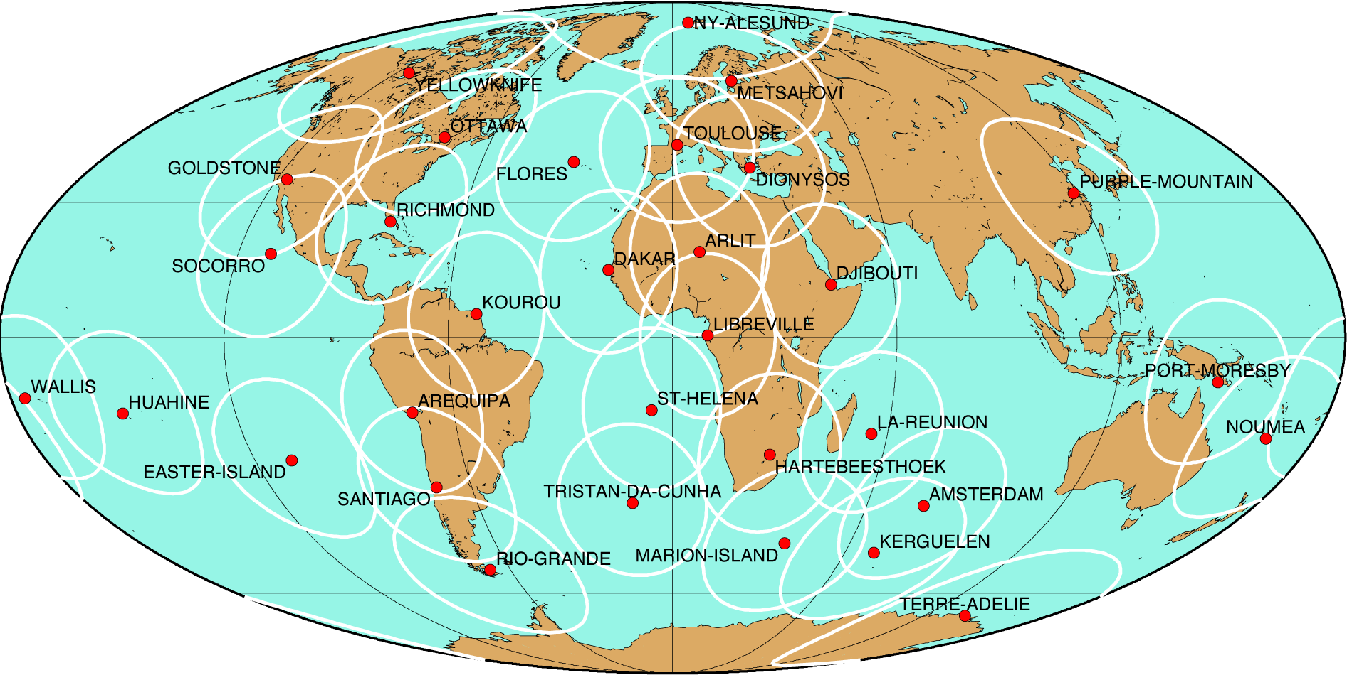

Figure ?: map of the DORIS network upon SPOT-2 launch (January 1990)

As of 1993, the network deployment went on at a slower pace. The number of stations reached 49 – roughly the initial objective of 50 stations – by the end of 1993. A few new stations were added, some existing ones had to be moved to new locations following the closure of host agencies facilities, or to improve their co-location with other geodesy techniques. All these new stations were equipped with the second generation antenna, and a few with the second generation beacon.

As of 2000, a general renovation was initiated, in order to improve the overall stability of the antennas reference point. Many stations were completely renovated or moved to a new location. A few new stations were installed, all meeting the new, more stringent requirements stability wise. The deployment of the third generation beacons started in 2002.

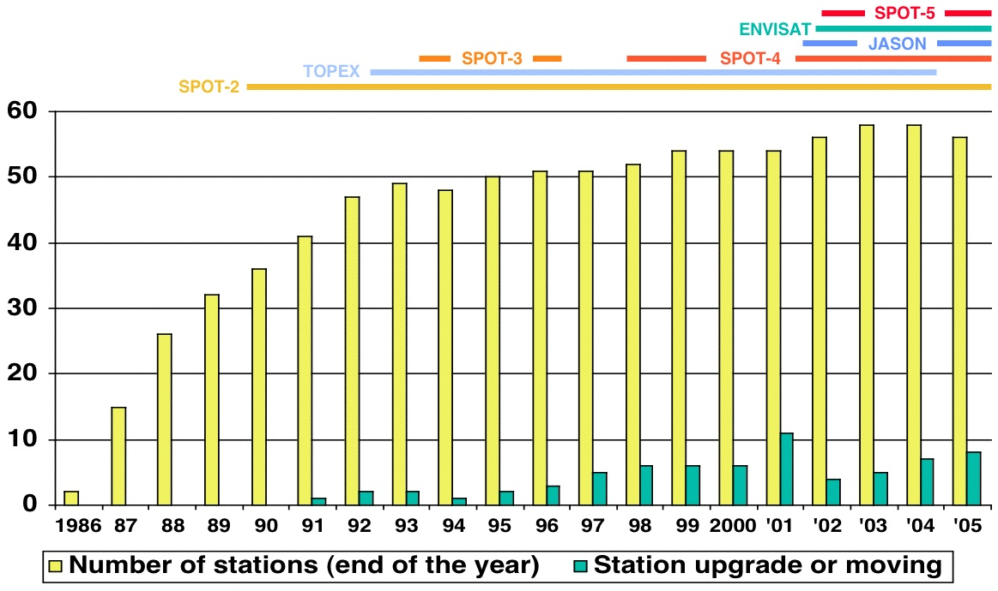

Figure ?: evolution of the DORIS network

5 THE DEPLOYMENT OF THE EARLY NETWORK: THE ALCATEL ERA

5.1 Description of the equipment

The first version of the equipment that made up a DORIS station consisted of:
- The beacon, version 1.0, manufactured by CEIS, France. This element (Figure ?), weighing 24 kg and designed to be integrated in a standard 19 inches rack, had to be installed inside a building with moderate temperature gradient. It could be programmed through an integrated man-machine interface consisting of a keyboard and a LCD screen. The beacon generates the DORIS signals: 401.25 MHz (6 W) and 2036.25 MHz (12 W).
- A box containing three 12V batteries, providing backup power to the beacon during power outages up to 72 hours.
- A weather station (Figure ?) measuring temperature, pressure and humidity. These parameters are transmitted through the 400 MHz modulated signal and can be used to correct for atmospheric propagation delays.
- A dual frequency and omni-directional antenna (Figure ?), manufactured by Alcatel. This antenna was bolted on an interface (consisting of a square horizontal plate welded to a vertical tube), which could be fastened to a variety of supports, in most cases a small lattice tower.

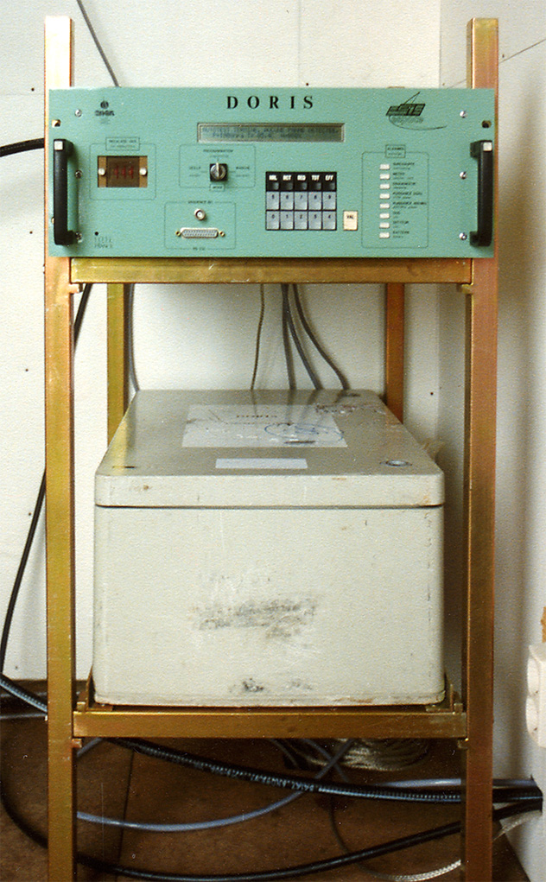 | 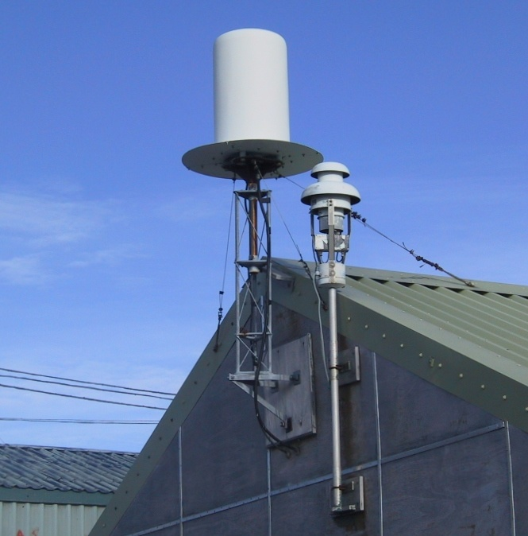
Figure ?:  DORIS beacon 1.0 (top) and Battery case (bottom) in a homemade rack | Figure ?:  DORIS Alcatel antenna (left) on a one-meter tower and side wall mount. DORIS meteorological station on the right.

5.2 Alcatel antenna layouts

In order to be able to adapt to the various site layout likely to be encountered, and for lack of detailed information allowing beforehand to determine exactly where and how the antenna and beacon would be installed, a standard set of antenna supporting devices was sent. This included several one-meter lattice tower sections, guy wires and a wall side mount for the antenna, and a home-made small rack for the beacon and batteries. The IGN technician who carried out the installation had to manage to find suitable locations for both the beacon and antenna, compatible with what was generally the most restrictive limitation of the DORIS equipment set: the very short – 10 m – cable length between the beacon and the antenna. In order to meet the good visibility requirement despite this limitation, many antennas had to be installed on building roofs or on top of two or three meter high towers, if not higher.

The most frequently used antenna support was a triangular, 17 cm sided, galvanized steel lattice tower made of two or three one-meter sections, bolted together and set up on one of the following structures:
- A concrete pad on the ground, already available (figure )
- A concrete block specially built for the DORIS installation (figure )
- A building’s top terrace. (figure )

At a few sites where the antenna was installed on a roof, a clear sky view allowed to use only one tower section. Conversely, four sections had to be used at a couple of locations in order to avoid nearby signal obstructions.

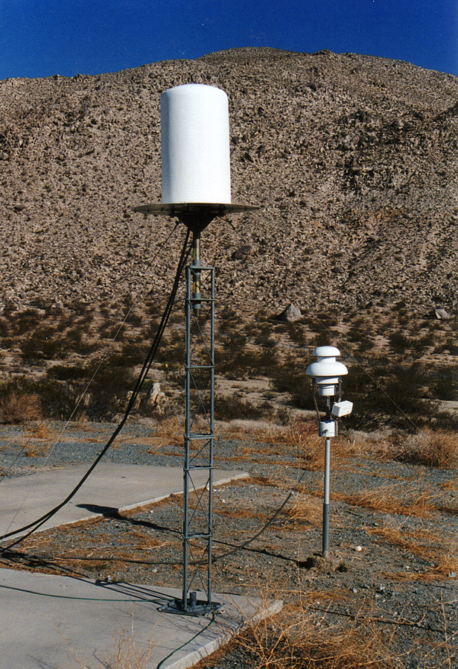 | 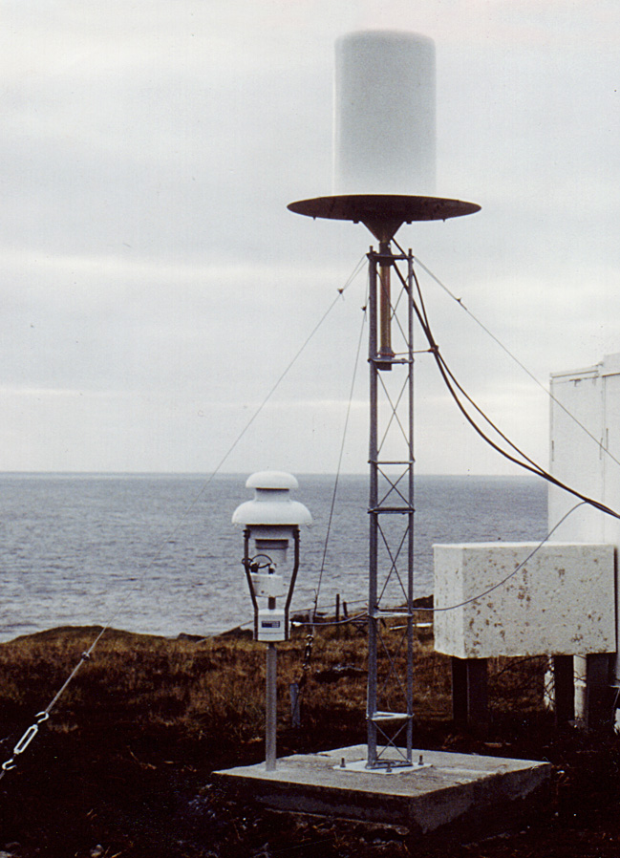 | 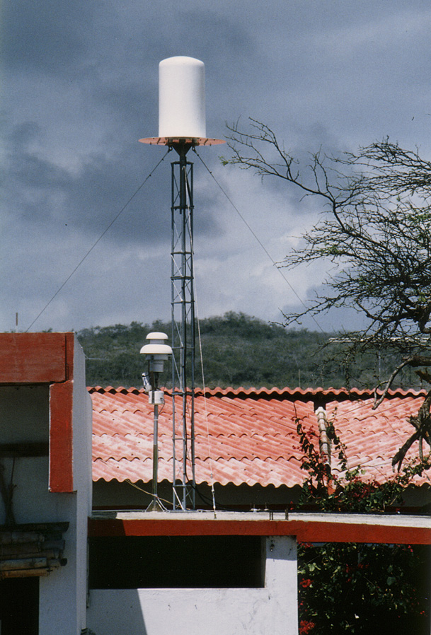
Figure ?:  2 m tower on a concrete pad  (Goldstone/GOMA) | Figure ?:  2 m tower on a concrete block  (Marion Island/MARA) | Figure ?:  3 m tower on the upper terrace of a building (Galapagos/GALA)

When such layouts were used, the tower itself was mounted on a square base plate, which was bolted to the concrete support using four expansion bolts. This base plate had a small vertical tube in its center, which prevented to see the ground mark if one had been set under the plate. In some cases the tube itself was used as the control mark instead. Such a control mark was destined to be used in the future to check the antenna stability on one hand, and as a marker of the antenna location in case of movement or accidental destruction of the antenna on the other hand.

Other designs have been used more rarely:
- Direct mount of the antenna interface on a roof, without using a tower (Figure ?)
- Steel pole instead of a tower (Figure ?)
- Tower mounted on a wall (Figure ?)
In a few of these cases, no ground mark was present.

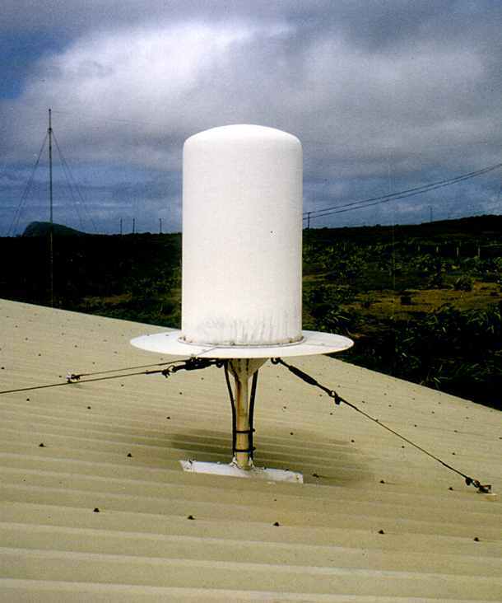 | 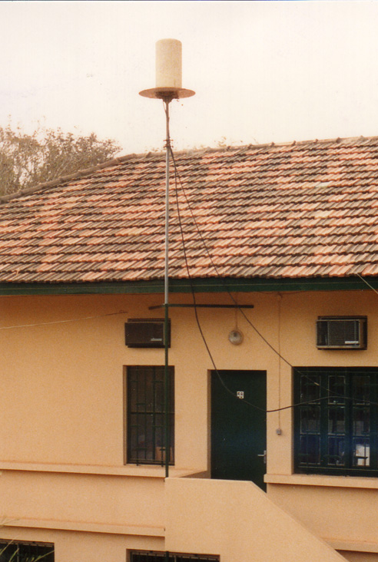 | 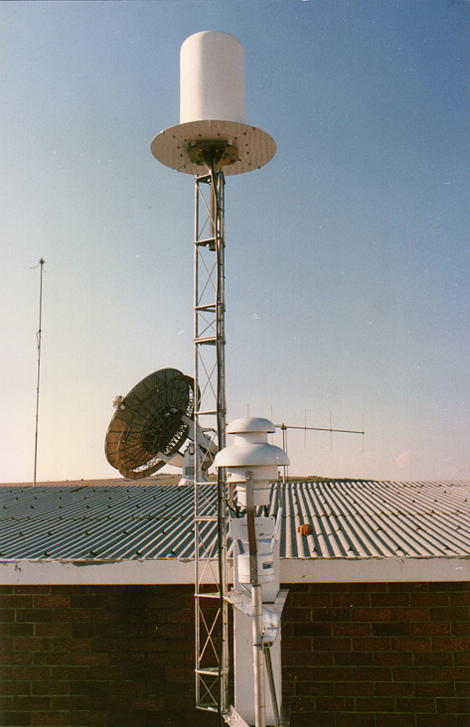
Figure ?:  Antenna interface mounted  directly on a roof ; no tower  (St Helena/HELA) | Figure ?:  High steel pole, propped by very long guy-wires  (Dakar/DAKA) | Figure ?:  Side mount of a 3 m tower against a load-bearing pillar. No guy-wires…  (Hartebeesthoek/HBKA)

Most towers were propped using stainless steel cable wires and turnbuckles, allowing a pretty strong and stable fastening of the tower. Nevertheless at a few sites the cable wires were very long or somewhat loose or even nonexistent, which would not guarantee a centimeter-level stability of the antenna. This was yet acceptable considering the expected positioning accuracy of the DORIS system at that time (10 cm).

By adjusting the tension of the stays, it was possible to center the antenna base (i.e. reference point) above the ground mark when present. However, none of the above antenna support designs allowed to precisely adjust the antenna verticality, i.e. to guarantee that the electrical phase centers – and notably the 2 GHz one on which the positioning measurements are performed – are on the same vertical line as the antenna reference point. This centimeter-level error could be ignored during the early years of the DORIS positioning, but it was taken into account when Alcatel antennas were surveyed prior to removal, during the network’ renovation phase. It is now far from being negligible taking into account the recent geodetic results obtained by the DORIS system (Cretaux et al. 2002; Willis and Heflin 2004)

6 THE NETWORK DENSIFICATION: THE STAREC ERA

A new antenna model started being used as of mid-1992, instead of the original Alcatel design, whose deployment ended in September 1992 with the installation of the two Australian stations at Orroral and Yaragadee. The number of stations in the network kept on increasing until the end of 1993, when it stabilized around 50 stations, before increasing again slightly at the end of the 90’s. During this period (1994 to 1999) several stations were moved to new locations, and a few had to be upgraded either following beacons failures or damages caused to antennas by strong storms. A second generation beacon was installed at a few sites as of late 1995 (first one at Krasnoyarsk), but was never deployed at a large scale, as a maximum of 14 units have been operating simultaneously in the network (in 2003).

6.1 Description of the second generation equipment

The new antenna model (Figure ?), manufactured by Starec, France, offered several improvements with respect to the original Alcatel model:
- Thanks to its slimmer design, it catches the wind far less, being therefore less prone to damage by storms,
- Its phase center location is better defined (to within 1 mm, vs 5 mm for the Alcatel antennas),
- Its slimmer and more rigid design allow a more precise survey and centering to be carried out.

From its very first deployments, this antenna model was mounted on a triangular plate machined at IGN’s mechanical workshop, linked to the underneath support by screws and nuts that allow a very fine adjustment of the antenna verticality. Three different materials have been used for this triangular plate: anodized aluminum, marine aluminum, and stainless steel. Unfortunately no exact record of the material used at each DORIS station was kept until the end of the 90’s, and we discovered after the event that corrosion had affected a few anodized aluminum plates, and caused a significant antenna tilt.

The new beacon (Figure ?), called “2.0 DORIS beacon” (Tavernier et al. 2003), manufactured by SOREP, France, had the following differences with respect to the original 1.0 beacon:
- Much lighter (8 kg) and compact,
- Waterproof casing allowing its deployment in more humid environments,
- External power supply (the internal one on the first generation beacons was the cause of most failures), in the form of a charger and two batteries in a dedicated waterproof box,
- Lower power consumption (30 W vs 120 W for the 1.0 model) allowing to install it in locations where electrical power supply is limited,
- User interface only through an external computer. The beacon itself has no indication telling if it is in the transmission or the standby mode.

The meteorological station associated with the second generation beacon had the same functionalities as the first model, but it was more compact and lighter.

Another apparently minor evolution equipment-wise during this period – the length of the antenna cables increasing from 10 to 15 m – had a significant influence in terms of antenna layout, as it allowed more freedom in the selection of the antenna location.

On the other hand, a modified version of the first generation beacon, called version 1.1, was developed. It consisted of a 1.0 beacon without the internal power supply unit – which was the cause of most beacons’ failures – connected to the power supply box of a second generation beacon. Very few such units have been deployed but they allowed to keep several stations operating at a time when the number of second generation beacons was not sufficient to replace the aging first generation ones.
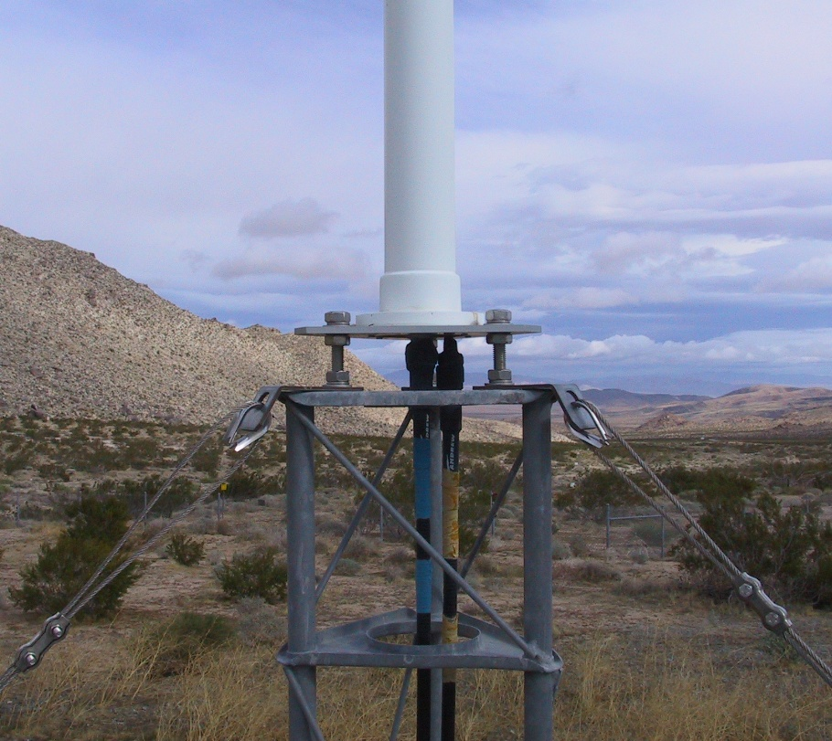 | 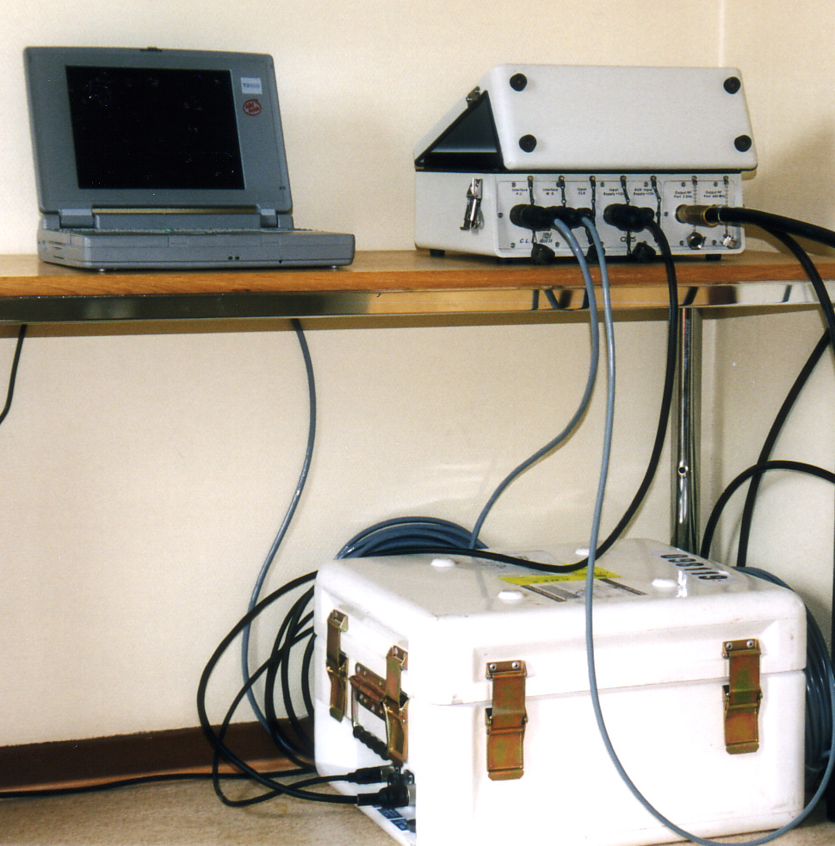
Figure ?  Base of the Starec antenna on a triangular plate mounted on top of a guyed lattice tower | Figure ?  The DORIS 2.0 beacon (upper right)  and its power supply (on the ground)

6.2 Starec antenna layouts

The antenna supports used during the 1993-1999 period were more or less standardized: most Starec antennas were installed, via the triangular plate, on a 2 meter high, 17 cm sided steel lattice tower, fastened with stainless steel guy-wires and turnbuckles (Figure ?). The base of the tower was bolted directly into the concrete support with three expansion or chemical anchors. A ground mark was always embedded in the concrete support, and would from then on be usable since the base square plate dealt with in chapter ? was no longer used. Using both the antenna triangular supporting plate adjustment nuts, and the turnbuckle, the antenna’s verticality and centering above the ground mark was carefully adjusted within one millimeter.

The exceptions to this standard layout were:
- The Alcatel antennas that had to be moved (e.g. following host agency premises closures) were generally relocated exactly as it was, using the same support. Several such relocations were carried out by the host agency with no intervention by IGN-F.
- 3 meter high tower (Cibinong/CIBB, Rio Grande/RIOB, Rapa/RAQB, Socorro/SODB, La Réunion/REUB) or even higher (6 m at Syowa/SYOB) when imposed by nearby signal obstructions (Figure ?).
- 1 meter (or less) high tower: with guy-wires at Santa Maria/SAMB and Krasnoyarsk/KRAB, no guy-wires at Everest/EVEB, Ottawa/OTTB, Papeete/PAPB (later moved to PAQB), Libreville/LIBB and Fairbanks/FAIB. The half-meter tower without guy-wires turned out to be very easy to install on top of a building’s wall while offering a very good rigidity, and was therefore retained during the renovation of the network dealt with in chapter ?.
- Direct installation of the antenna triangular supporting plate on a concrete pillar, using three short threaded rods embedded into the concrete. This very stable design was first used in February 1997 at Ascension/ASDB, then at Amsterdam/AMSB, Syowa/SYPB and St John’s/STJB.
- A very rigid 3 meter steel pole was used at Mount Stromlo/MSOB.

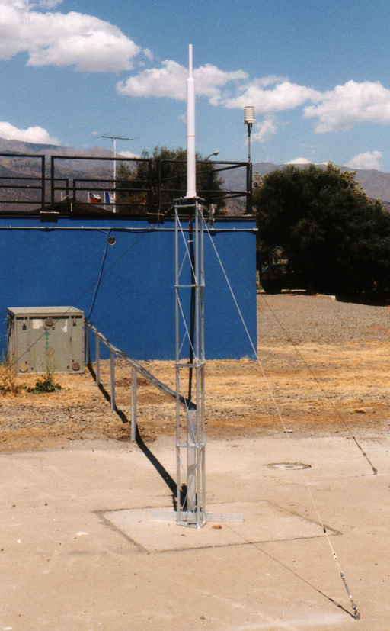 | 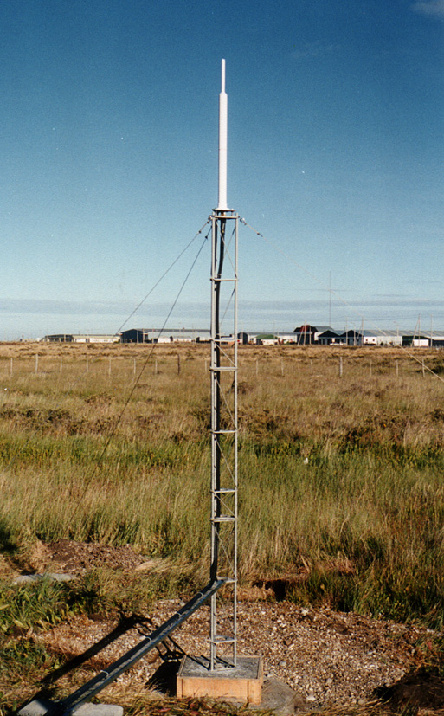 | 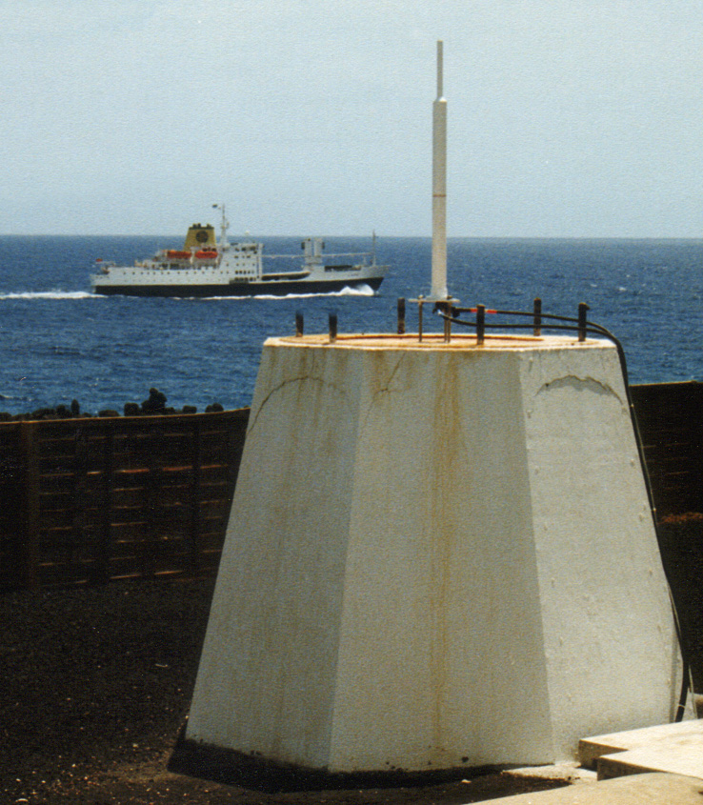
Figure ?  Standard layout:  2 meter tower, guyed  (Santiago/SAOB) | Figure ?  3 meter tower, guyed  (Rio Grande/RIOB) | Figure ?  The first DORIS antenna mounted on a concrete pillar (a former antenna pedestal)  (Ascension/ASDB)

7 THE RENOVATION ERA

The need for an improvement of the DORIS antennas stability emerged in the mid-90’s, after the increasing positioning accuracy of the DORIS system allowed it to be accepted as a new technique for the realization of the IERS Terrestrial Reference System (Boucher et al. 1994; 1996), leading to the latest ITRF2000 (Altamimi et al. 2002). When an existing station had to be moved, or when a new one was installed, increasing attention was paid to install the antenna on a very stable support like those described in the previous chapter (Fagard and Orsoni 1998). Such a policy has been applied until the end of the 90’s, with no on-site intervention motivated only by the need for an antenna stability improvement during this period. Guy-wires were still used to fasten antenna supporting towers, although they were installed with more care than in the early years of the DORIS network (3 guy-wires at 120 degree spacing, identical lengths, stainless steel hardware).

At the end of 1999 a global renovation action, aiming at improving the stability of the antennas, was decided. This renovation project was presented to the DORIS community during the “DORIS days” in May 2000 (Fagard and Orsoni 2000), and actually started with the renovation of the Djibouti station in July 2000.

7.1 Network preliminary review

In order to plan this renovation action, it was first necessary to review the situation at all DORIS sites, in order to determine if a stability improvement was necessary, and how urgent it was. Such an evaluation took the following parameters into account:
- The type of antenna (Alcatel or Starec). Although no antenna can be considered more stable per se, the Alcatel antenna has several characteristics – higher sensitivity to the wind, less accurate survey, no verticality adjustment – that allows to consider it as less stable a priori.
- The kind of antenna support (metal tower with or without guy-wires, concrete pillar, other designs).
- The nature of the structure this support was installed on (building, rock, concrete block, etc.).
- The date of the installation, as recent installations could reasonably be considered of better quality.

This resulted in a one to three star stability grade given to each antenna (Fagard and Orsoni 2000). This evaluation was later refined for internal use by IGN-F, into four categories defined as follows:

Category | Examples of layout | Comments
Excellent | Concrete pillar on rock, or with deep foundations.  Self-supporting tower on a concrete structure on the ground.  Starec antenna only. | The objective to achieve for the whole network
Good | Self-supporting tower on a concrete structure with not so deep foundations.  Rigid tower on a building  Starec antenna only. |  | The secondary objective, when local constraints prevent from achieving the “excellent” status.
Dubious | Guyed tower on the ground (up to three meters) or on a building (up to two meters), recently installed.  Early days setups if rigid fastening to a low elevation building. |  | Applies to most “standard layouts” installed during the Starec Era (chapter ?)
Poor | Towers (> 3 m on the ground, > 2 m on buildings, or poorly guyed, or installed a long time ago). |  | Most original layouts from the early stations (chapter ?)

These apparently objective evaluation criteria were modulated by a subjective feeling on the antenna support overall quality. The resulting stability estimate for the whole network is shown on Figure ?.

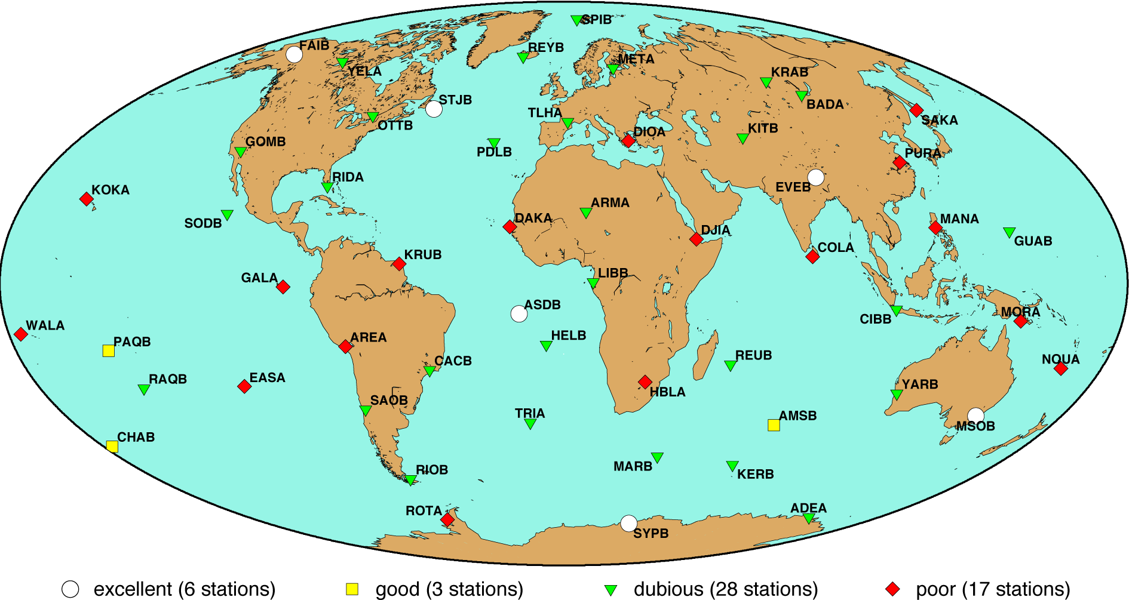

Figure ?
Map of the DORIS network at the end of 1999, showing the estimated stability of the antennas

It is important to note that the purpose of such an estimation was only to allow us to properly manage the network renovation and monitor its progress. The resulting estimate should neither be regarded as an indicator of the quality of the stations’ computed coordinates and velocities, nor be used to classify them, since the actual stability of an antenna can only be properly assessed by surveying it at different epochs with respect to a stable reference mark. A more refined stability assessment will be presented in chapter ?.
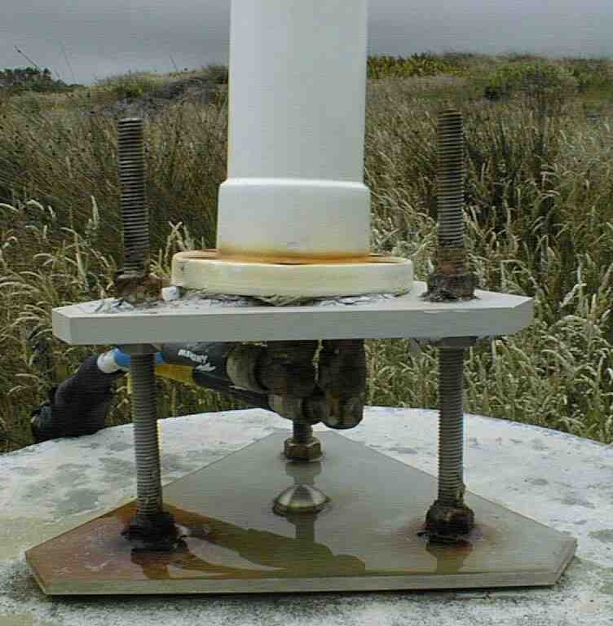
Figure ?
Antenna tilt resulting from the corrosion of the base plate
(Amsterdam/AMSB)

Moreover, this was a theoretical approach, and the actual behavior of the antennas did in some cases differ significantly from our expectations, for better or for worse:
- Corrosion of the antenna triangular base plate (the anodized aluminum type) caused a several centimeter antenna tilt on a concrete pillar, for an “excellent”-rated antenna support (Figure ?: Amsterdam/AMSB) (Willis and Ries 2005).
- The antenna centering turned out to be still within a few mm after more than ten years for several Alcatel antennas installed during the very early years of the DORIS network, hence rated “poor”.

7.2 Quality requirements and monumentation designs

Requirements

In order to be compatible with the expected, and almost achieved accuracy of the DORIS positioning system at the centimeter-level, the objective in terms of stability of the DORIS antenna reference point was defined as one centimeter over ten years. Such a requirement had the following consequences on the design of the antenna supports that would be used for all future installations and for stations renovations:
- Guy-wires should no longer be used to fasten a supporting tower and adjust the antenna centering. Although such a design turned out to be very stable over many years, it is not 100% reliable, as accidental damage, or progressive slackening of one stay will result on an antenna horizontal shift, either sudden or progressive, that may go unnoticed locally for quite a while.
- Only the antenna supports described below should be used.

Design 1: concrete pillar

The preferred antenna support is a concrete pillar (figure ?), built according to “geodetic” specification, who take into account the nature of the ground. The pillar designs show on figures ?, ? and ? have been derived from those used by the Canadian Geodetic Survey Division [Geodetic Survey Division, 1993]. A triangular plate is set on three A4 stainless steel embedded in the concrete pillar, and a series of nuts allowing to adjust the antenna verticality. The triangular plate, machined by IGN-F mechanical workshop, is made of either high quality stainless steel (AISI 316 L) or marine aluminum. Such a pillar should nevertheless be smaller than two meters in order to limit the antenna movements caused by the difference in thermal expansion of both sides of the pillar.
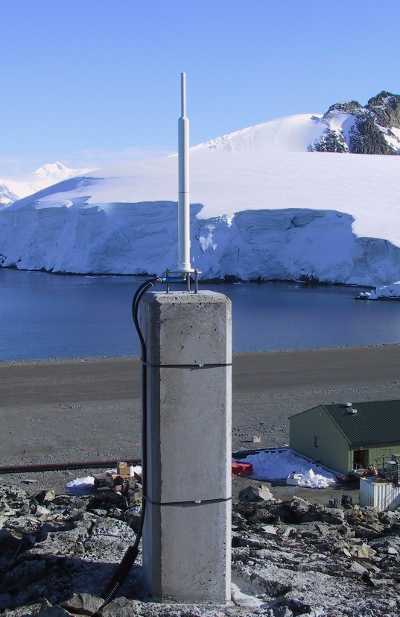
Figure ?
Concrete pillar on rock.
(Rothera/ROTB)
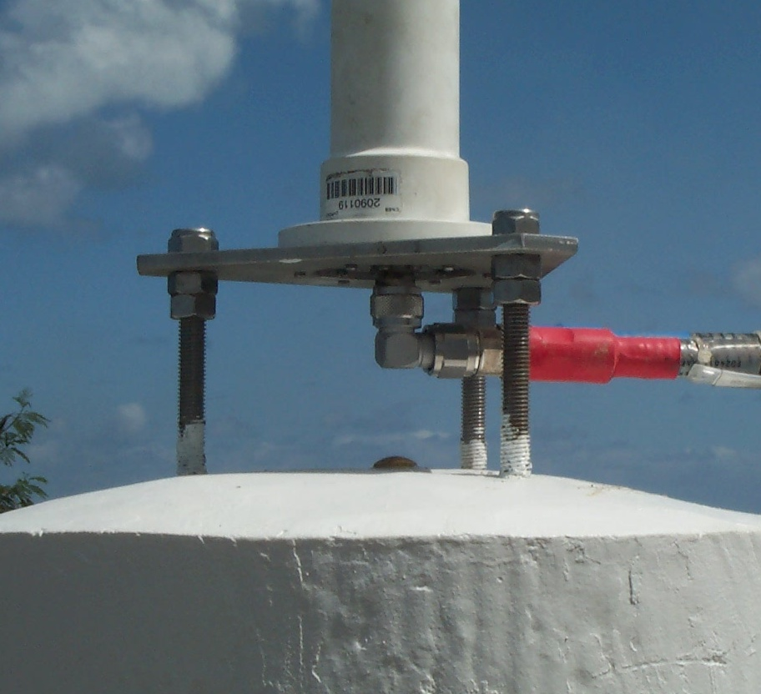
Figure ?
Base plate embedded in a pillar.
(Nouméa/NOWB)

Figure ?  Pillar design when bedrock is present near the ground surface | Figure ?  Pillar design for hard soil pillar  Dimensions may vary depending on soil hardness | Figure ?  Pillar design for soft soil pillar  Dimensions may vary depending on soil hardness

Design 2: self-supporting metal tower

The second preferred support is a very rigid lattice tower (self-supporting type, not requiring guy-wires). Such a tower is installed on a very stable concrete structure at ground level. This concrete base is built according to the same specifications as the concrete pillar described above. In a few cases, existing concrete structures were used if they were in good condition and their dimensions seemed to guarantee a good long term stability.
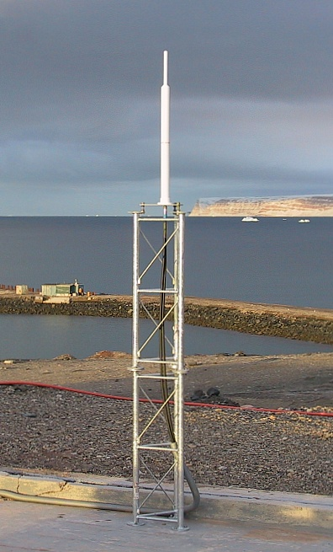
Figure ?
(Male/THUB)

This tower design is used when surrounding signal obstructions (often caused by the very building that hosts the DORIS beacon) requires that the antenna be higher on the ground than what a concrete pillar allows. It is also used when a good quality concrete base is already available, allowing an easier and cheaper installation than specially building a concrete pillar.

Finding strong enough lattice towers, available in one-meter sections (that fit easily even in the small airplanes that service some very remote DORIS locations) was not a easy quest. After trying a first model (installed at Santiago/SANB and Easter Island/EASB) whose finish leave to be desired, 32 cm sided, galvanized steel towers manufactured by Leclerc SA, France, have been used at many DORIS stations and turned out to be satisfactory (figure ?). This tower model has an additional advantage: it can also support the Vaisala meteorological station after the standard installation set was slightly modified (figure ?).

Design 3: antenna on a building

At a few DORIS stations, even putting the antenna on a two meter tower, set on a concrete block protruding 30 cm or so off the ground – which puts the lowest phase center almost three meter above the ground – is not sufficient to give enough clearance because of high nearby signal obstructions. In such cases, the only option is to put the antenna on a building, generally the one where the indoor DORIS equipment is located. Such a layout can give satisfactory results stability wise, provided the following precautions are taken:

- The location where the antenna support is installed should be carefully selected with respect to the structure of the building, in order to achieve as good as possible a long term stability. Ideally, the antenna support should be installed on top of a load-bearing pillar, or at the corner of two load-bearing walls. If such a solution is not achievable, the best approaching one is sought (e.g. not putting the antenna on the center of a slab roof but rather near the junction to the underneath load-bearing wall). If necessary, the construction drawing of the building or advice from the builder can be used.
- The antenna support is as small as possible. Putting the antenna on top of a building allows to save a few meters and hence to sometimes get rid of most signal obstructions, therefore the antenna can be put on a very short tower. Using only one section of a 32 cm sided tower, or a half-meter 17 cm sided one – which has the additional advantage of fitting on narrow concrete beams – guarantees an optimal rigidity of the support.
- When possible, the tower should be bolted or embedded directly in the underneath load-bearing structure. This requires special precautions when a waterproof coating covers the roof.

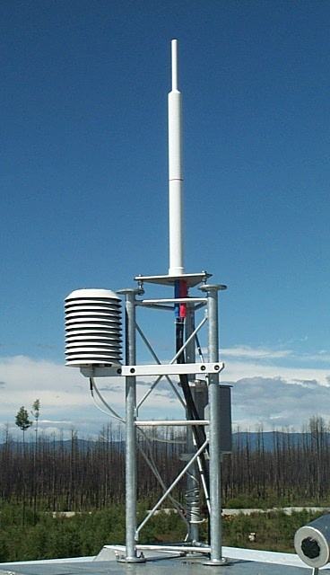 | 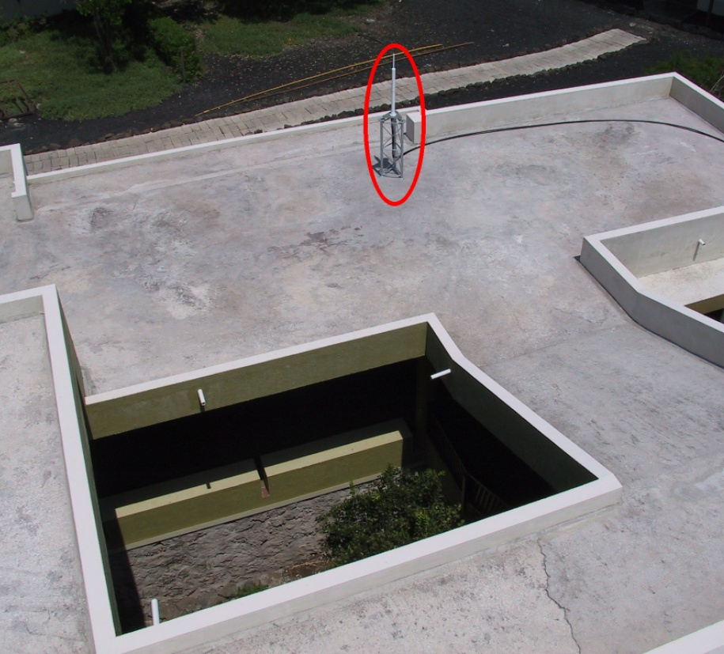  Figure ?  One-meter tower on the roof slab of a building | 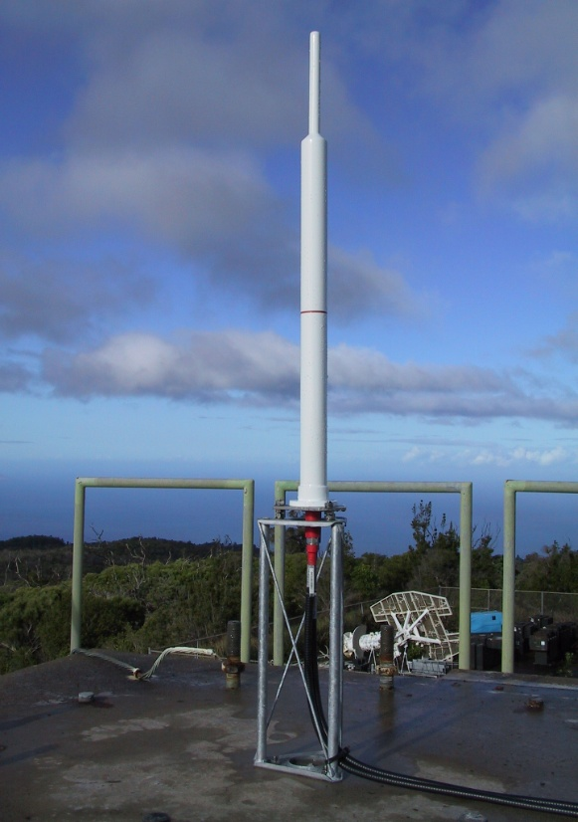
Figure ?  One-meter high, 32 cm sided tower on roof.  (Badary/BADB) | with a very involved structure.  The tower is not “somewhere on the roof”, but exactly on top of a load-bearing concrete pillar.  (Santa Cruz/SCRB) | Figure ?  Half meter high, 17 cm sided tower on top of a building.  (Kauai/KOLB)

The third generation beacons

A new generation of beacons was introduced, and deployed as the renovation was progressing (Tavernier et al. 2003), with the first one “standard” beacon – i.e. apart from the master beacon at Toulouse – being installed at Tristan da Cunha in January 2002. Their development was stopped for a while as of February 2004 after a serial failure on the 2 GHz channel had been discovered, and resumed in July 2004 with retrofitted units.
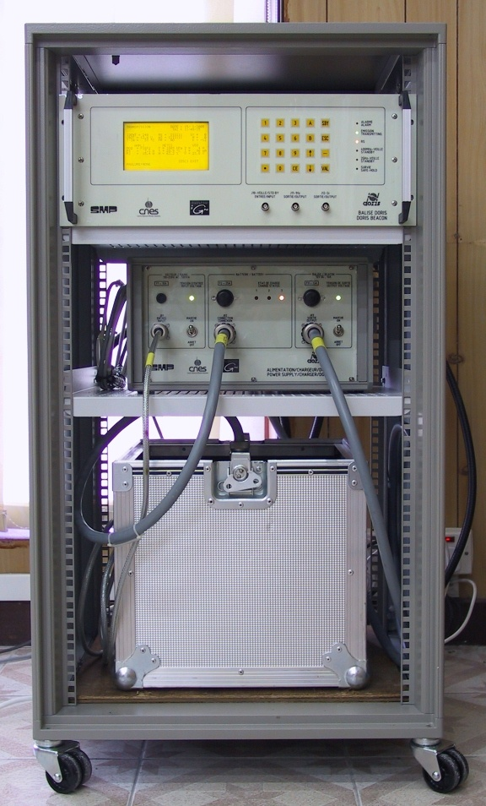
Figure ?
3rd generation beacon, charger and backup battery in a 19” rack

This new set of equipment (figure ?) is composed of:

- The beacon, version 3.0, manufactured by SMP, France. Its appearance is very similar to the first generation one, with a bigger LCD screen and a more sophisticated man-machine interface. It should be installed inside a building and fits in a standard 19 inches rack. The power consumption is approximately the same as the first generation one (130 W). Contrary to the previous models, the signal is modulated on both channel.
- A charger that supplies power to the beacon and monitors the charge of the backup battery.
- Three different configurations (30 Ah, 110 Ah and 220 Ah) for the 12V battery.
- The weather station (Figure ?) is a Vaisala PTU200 unit.
- The antenna (Starec model) is unchanged.

7.3 The progress of the renovation

As can be seen on figure ?, there has been a steady and definite improvement of the network quality stability-wise between 2000 and 2005. During this six year period the following evolutions have been taking place:

- 31 existing stations were renovated (at least 3 per year, and up to 10 in one year),
- 4 stations were added to the network,
- 8 new stations were installed as a replacement for existing ones which have been closed,
- 2 stations have been removed and not yet replaced (Arlit and Guam).

The renovation turned out to be a much longer and complicated process than we first expected. The more stringent requirements for the antenna stability required to gather a lot of information about the site (pictures, sketches, obstruction diagrams if available). Even though a contact with the host agency had been established for many years, sometimes long time to answer and the need to plan logistical aspects in detail – especially when a concrete monument had to be built – involved that the whole process could take well more than one year, and require that well more than 100 e-mail messages be exchanged between IGN and the host agency. This is even more true for the installation of a new site ex nihilo, with a couple of projects extending over up to three years before being eventually carried to a successful conclusion.

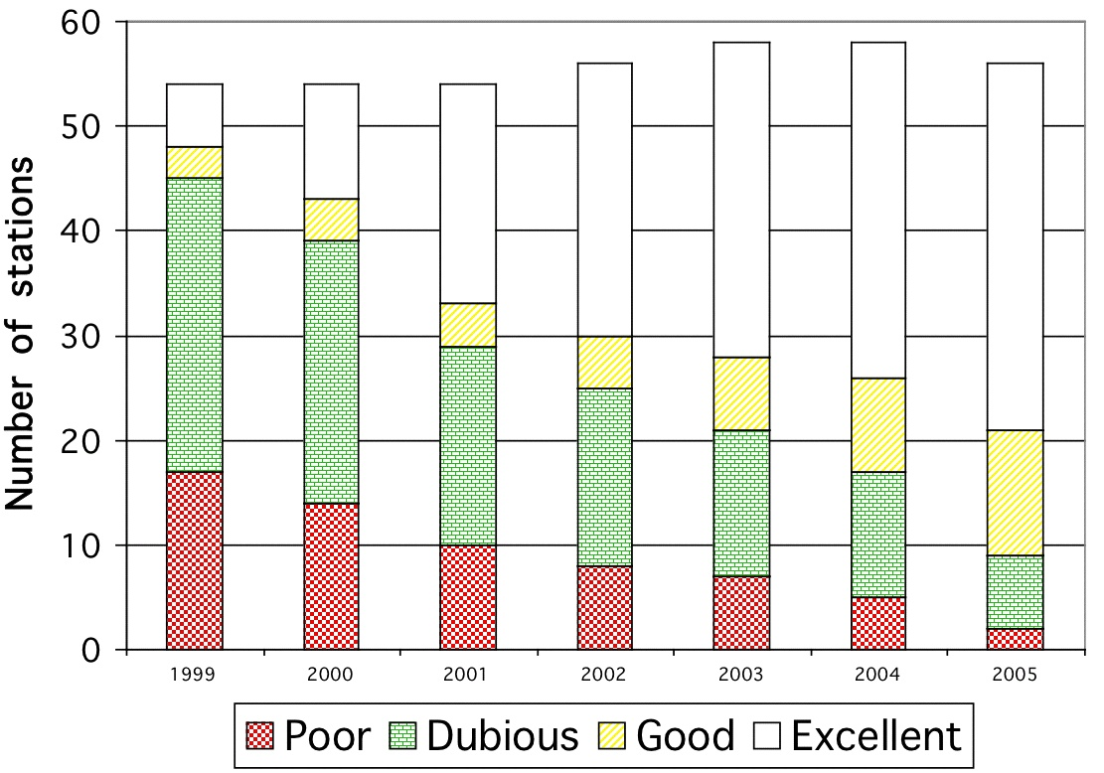
Figure ?
Improvement of the estimated antenna stability

8 THE NETWORK MAINTENANCE

8.1 Maintenance running

In addition to the deployment of the network, IGN-F has also been in charge of its maintenance, the operation of which can be summarized as follows (figure ?):

- An anomaly is detected by the DORIS control center, either in the form of a complete lack of measurements, or of a wrong parameter (time set, frequency, meteorological parameters, power cut, etc.);
- The DORIS control center (Jayles et al. submitted) sends – for each anomaly detected – an intervention request to IGN’s maintenance unit (SIMB: Service d’Installation et de Maintenance des Balises = beacons installation and maintenance service);
- IGN contacts the host agency, asking it to carry out the necessary operation;
- The host agency performs the requested operation, and reports to IGN, which then reports back to the DORIS control center.

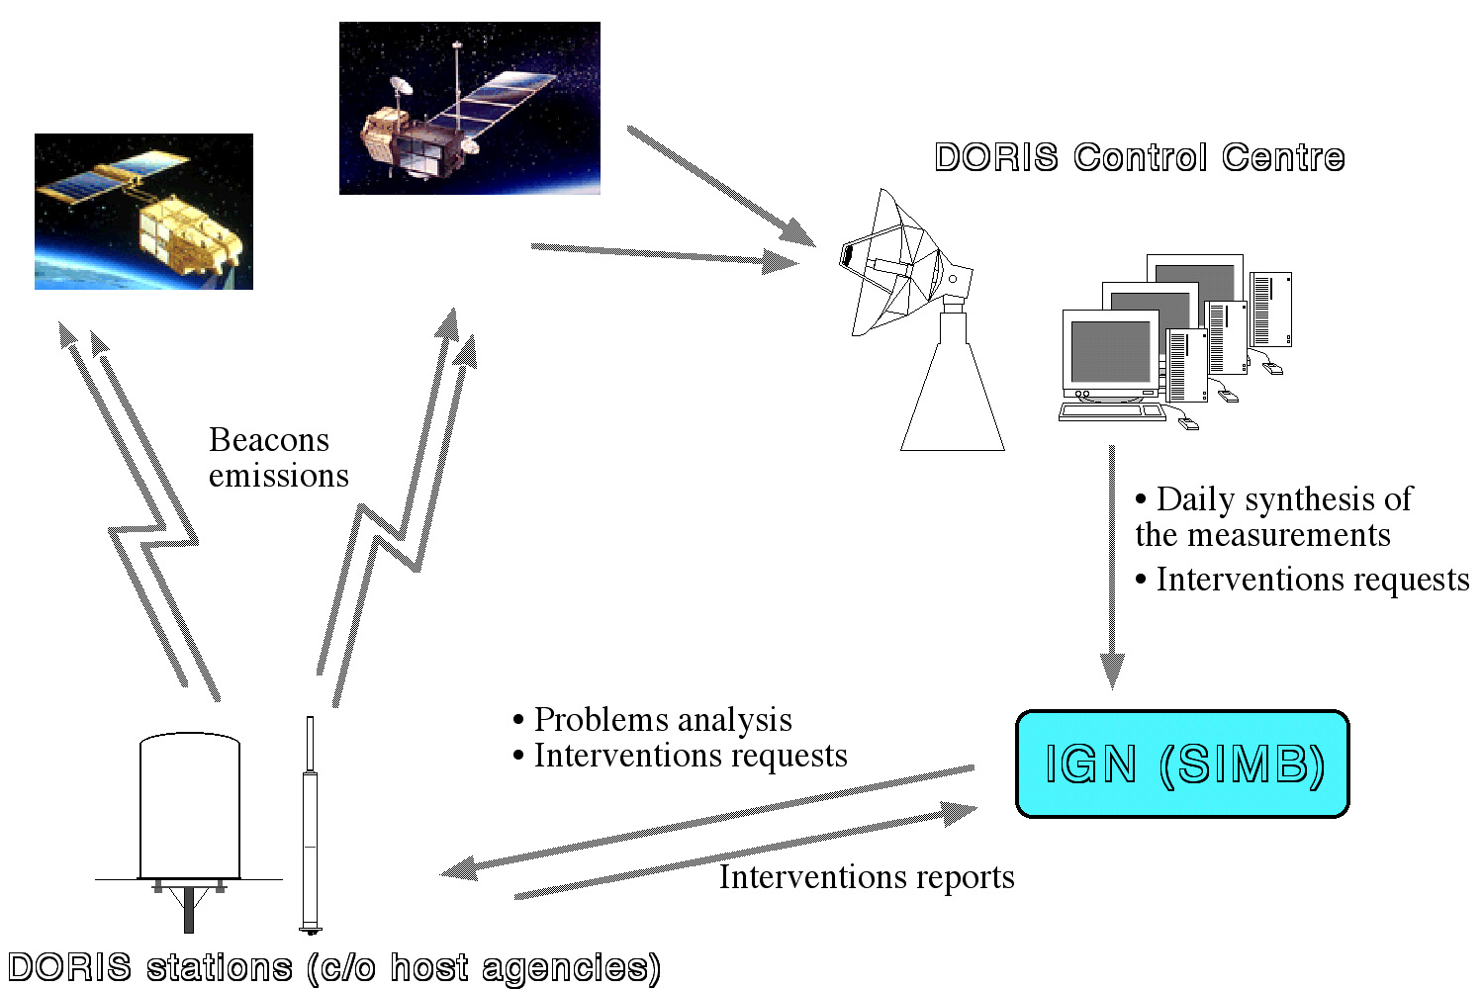

Figure ?
Measurements and maintenance flow

The following types of operations are likely to be requested to the host agency :
- Time or frequency adjustment,
- Reset of the beacon after a failure (automatic for the third generation beacons),
- Checking through a self-test procedure,
- Battery charging or replacement,
- Replacement of the weather sensors,
- Exchange of the beacon by a spare sent by IGN. No on-site repairs are carried out by the host agency.

8.2 Maintenance statistics

Equipment reliability has been a major issue throughout the life of the DORIS network. The proportion of emitting beacons in the network averages to about 85 %, with lows at 80 % and highs reaching 95 %. Because of very long repairing delays and frequent shortages of spare units, a few stations have remained down for several months before they could be replaced. This rate nevertheless allows the global coverage rate – ratio of time during which the on-board instrument receives a signal – to remain at a good level, thanks to the density and homogeneity of the network. This coverage rate, whose maximum theoretical value is 93% for high altitude satellites like TOPEX/Poseidon and Jason-1 (both at 1330 km altitude), is still 80 % when 20 % of the stations are down.

Each generation of beacons has had its own share of specific problems:
- The first generation beacons’ main source of problems was the internal power supply (70 % of the failures). Other failures were due to the oscillator or to the synthesizer.
- An amplifier problem on the second generation beacons caused a few month interruption in their deployment around 1996. Apart from this temporary anomaly, which was corrected as of 1997, this model did not turn out to be more reliable than the first generation. In 2005 a new problem (power supply defect creating spurious in the signal) was detected, which will require the replacement of the remaining units by third generation beacons.
- Almost all third generation beacons installed between early 2003 and August 2004 have been affected by a failure on the 2 GHz channel, which required these units to be retrofitted. After this problem was solved, the deployment of this model has resumed, either on the occasion of a major site renovation or by simply shipping a new model to the host agency who took care of its installation. From then on, the operating rate for this model has increased to ?? %.

Because of the shipment waiting period, customs formalities and scarce service to some remote DORIS locations, the necessary time to have a spare beacon delivered on site can vary tremendously, between a couple of weeks to as long as one year.

From the start of the DORIS system operation, IGN’s maintenance unit has been handling about 150 intervention requests and ?? beacon exchanges a year on average.

9 THE CURRENT NETWORK STATUS

9.1 The current network configuration

The distribution of the different equipment types in the permanent network (56 stations) is currently (February 2006) :

- 42 third generation beacons,
- 7 second generation beacons,
- 7 first generation beacons (including one 1.1 beacon at Socorro)
- 54 Starec antennas
- 2 Alcatel antennas

9.2 The host agencies

9.3 The antenna stability evaluation

10 DORIS: A SPACE GEODESY TECHNIQUE

10.1 Definition of the antennas reference point

10.2 Determination of a priori coordinates

Prior to the launch of the first DORIS instrument on board SPOT-2, IGN published an initial set of coordinates for the DORIS network, labeled JCOD0. These coordinates were expressed either in the BTS87 realization of the BTS system (BTS: BIH Terrestrial System, the predecessor of the ITRS) or in the early realizations of the ITRF: ITRF88 or ITRF89. The reference epoch was 1984.0. This set of coordinates was later complemented as new stations were deployed after the start of the DORIS system’s operation, in the form of updates of the initial set, labeled JCOD0.n.

Such geocentric coordinates could be obtained in different ways (Boucher and Fagard 1991), from the geodetic tie between the DORIS antenna and another geodetic point in the vicinity:
- If the DORIS antenna was tied to a VLBI antenna or SLR telescope, which were generally already part of the BTS87 or ITRFnn solution, the accuracy of the resulting coordinates was better than 10 cm.
- If the DORIS antenna was tied to a Doppler Transit point, either already determined or observed simultaneously to the DORIS installation, the resulting coordinates had to be transformed from the ephemeris system (such as NSWC-9Z2, NWL-9D or WGS84) into BTS87 using a seven parameter transformation (BIH 1988). The resulting coordinates accuracy was around one meter if precise ephemerides had been used in the computation of the Transit point, vs 2 to 10 meters with broadcast ephemerides.
- In a few cases, the DORIS antenna could only be connected to the local geodetic network, and the coordinates expressed in the national datum were transformed to BTS87 using available transformation parameters, notably those determined by the Defense Mapping Agency. Depending on the accuracy of the transformation used, the resulting accuracy for the coordinates was between 2 and 10 meters.

A COMPLÉTER

Co-locations with other IERS techniques

11 PLANNED EVOLUTIONS

12 CONCLUSION

References

Altamimi Z, Sillard P, Boucher C (2002) ITRF2000, a new release of the international terrestrial reference frame for earth science applications, J Geophys Res Solid Earth 107(B10):2214, doi:10.1029/2001JB000561

BIH (1988) Annual report for 1987. Observatoire de Paris.

Boucher C, Fagard H (1991) DORIS stations coordinates. Proc International DORIS orbit computation workshop, Toulouse, Oct.

Boucher C et al. (1994), Proposal to include DORIS as a new technique in IERS. Rapport Technique GRGS n°12.

Boucher C et al. (1996), Results and analysis of the ITRF 94. IERS technical note n° 20.

Cabanes C, Cazenave A, Le Provost C (2001) Sea level rise during past 40 years determined from satellite and in situ observations. Science 294(5543):840-842.

Cretaux JF, Soudarin L, Davidson FJM, Gennero MC, Berge-Nguyen, Cazenave A (2002) Seasonal and interannual geocenter motion from SLR and DORIS measurements, Comparison with surface loading data. J Geophys Res Solid Earth 107(B12):2374.

Douglas B (1991) Global sea level rise. J Geosphys Res Oceans 96(C4):6981-6992.

Fagard H, Orsoni A (1998) The DORIS network: review and prospects. Proceedings of the DORIS days, Toulouse, April.

Fagard H, Orsoni A (2000) Current status and evolution prospects of the DORIS network. Proceedings of the DORIS days, Toulouse, May.

Jayles C, Mhun-Fat B, Tourain C (submitted) DORIS, System description and control of the signal integrity. J Geod same issue.

Nerem RS, Haines BJ, Hendricks J, Minster JF, Mitchum GT, White WB (1997) Improved determination of global mean sea level variations using TOPEX/Poseidon altimeter data. Geophys Res Lett 24(11):1331-1334.

Tavernier G, Granier JP, Jayles C, Sengenes P, Rozo F (2003) The current evolution of the DORIS system. Adv Space Res 31(8):1947-1952.

Tavernier G, Fagard H, Feissel-Vernier M, Lemoine F, Noll C, Ries J, Soudarin L, Willis P (2005) The International DORIS Service (IDS). Adv Space Res 36(3):333-341, DOI: 10.1016/j.asr.2005.03.102

Wessel P, Smith W (1998) New, improved version of the Generic Mapping Tools released. EOS Trans. AGU, 79, 579.

Willis P, Heflin M (2004) External validation of the GRACE GGM01C gravity field using GPS and DORIS positioning results. Geophys Res Lett 31(13):L13616.

Willis P, Ries JC (2005) Defining a DORIS core network for Jason-1 precise orbit determination based on ITRF2000, Methods and realization. J Geod 79(6-7):370-378.

Willis P, Boucher C, Fagard H, Altamimi Z (2005) Geodetic applications of the DORIS system at the French Institut Geographique National, CR Geoscience 337(7):653-662, DOI:10.1016/j,crte.2005.03.002

